Your June Social Media Post
June is Great Outdoors Month! Simply being outside can improve your mood and health. Learn more about the benefits of the outdoors through the ERS Wellness Webinar this month featuring Rodney Franklin, Director of Texas State Parks at Texas Parks and Wildlife. Register through the ERS Wellness Events Calendar.

2. Enjoy a peaceful moment today, take some time for yourself outside.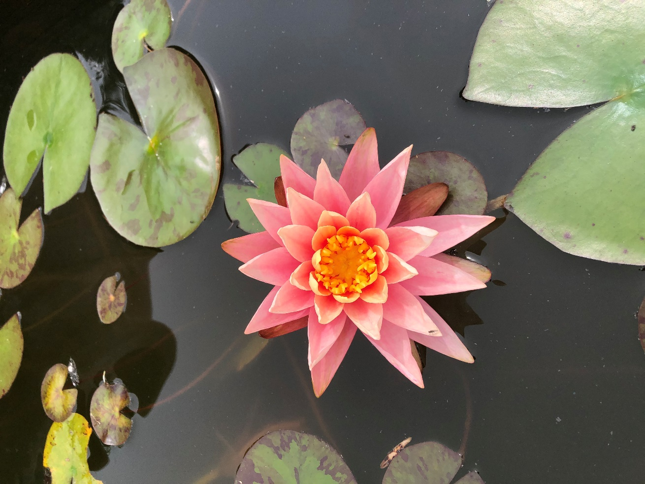

3. [photo needs a watermark that says Kuhlken Photography or Facebook post needs to tag Kuhlken Photography ]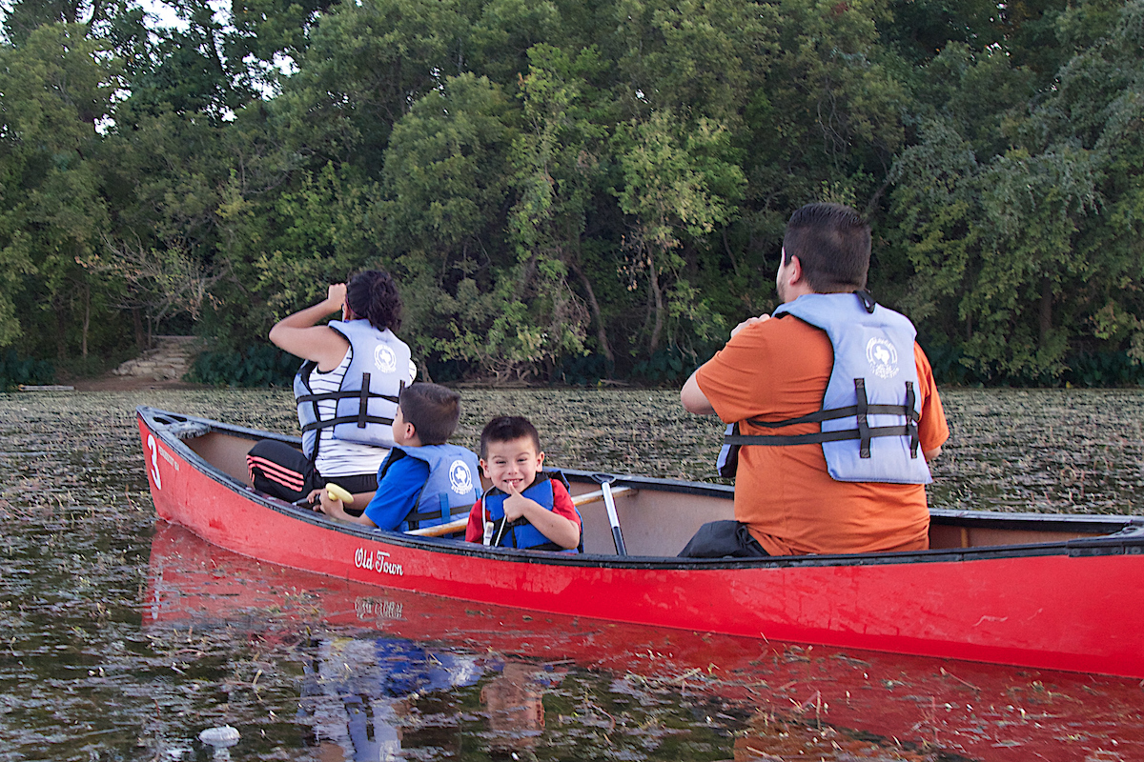Connect with your inner wild child. Did you know that spending time in a park or other natural setting can improve your mood, reduce stress and increase your ability to pay attention? Make time to spend a couple of hours each week outdoors and FEEL the difference!

4. [photo needs a watermark that says Kuhlken Photography or Facebook post needs to tag Kuhlken Photography]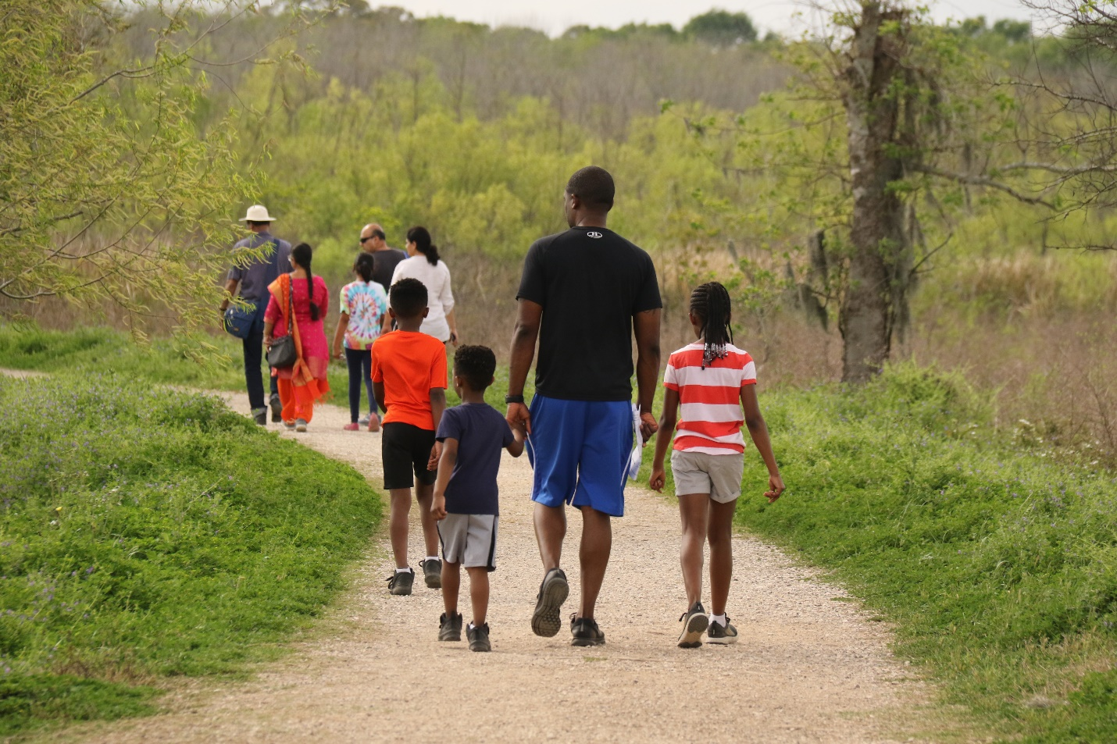
Research shows we are more likely to feel healthy – both physically and mentally – when we spend 120 minutes each week in green spaces, like local parks, either all at once or spaced over several visits. Get to know the green spaces in your area during #GreatOutdoorsMonth
[source: https://e360.yale.edu/features/ecopsychology-how-immersion-in-nature-benefits-your-health ]

