May 2020 Interview with Director Rodney Franklin, Texas Parks & Wildlife Department (TPWD)
June is Great Outdoors Month and who better to talk to about getting outside than one of our own ERS health plan participants, the Director of State Parks for the Texas Parks and Wildlife Department, Rodney Franklin? Director Franklin started his journey with TPWD at the age of 17 and, throughout his career, has continued to inspire others to embrace the outdoors. ERS and TPWD have a shared mission of improving the health of Texans and one of the easiest ways to improve your health is to spend time outside. . We hope you enjoy this Q&A with a truly inspirational leader.

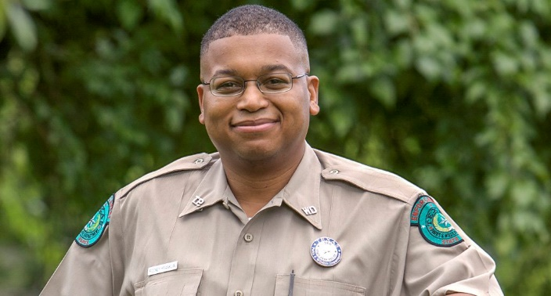
Where were you when you first found your love of the outdoors?
My love of the outdoors came from crappie fishing with my dad every Saturday on Pat Mayse Lake and Lake Crook near Paris, Texas. We had a small boat. Mom would pack lunches for us and we would spend the day on the lake catching fish at our favorite fishing spot we called the “Crappie Hotel.” My love of the outdoors was solidified by a scout master who was an avid outdoorsman. During my time in Boy Scouts, I learned to camp, hike, use orienteering skills and do all kinds of other activities that connected me to nature. I would not have experienced that side of the outdoors without that scouting experience.
Rodney Franklin, Director of Texas State Parks

What is your favorite outdoor activity and why?
Tough one here. I would have to say fishing and hiking. They were among my first loves and hiking is easier for me to accomplish these days. I also like finding a quiet spot and simply enjoying the serenity of the sights and sounds of nature. I will say that my ability to do this successfully has grown with age 😊. My teenage self would be confused by this activity.

Why do you think being outdoors is so important for people and families?
There are so many proven benefits to mental and physical health and well-being. Being outside can have a calming effect on people. It can bring people together. My dad and I solved many a world problem all those years ago on the lake. Outdoor physical activity like hiking can improve heart health and be a wonderful and enjoyable way to spend quality time with friends and loved ones.

If someone is interested in spending more time outdoors but is intimidated and doesn’t know where to start, what do you recommend?
One of my first thoughts is to start locally. Many folks start with walking in their own neighborhoods, at a local greenbelt, or at a city or county park. Also, finding a friend with whom you can walk or explore with can provide some comfort. Doing some research online can provide some tips for beginners as well as provide information on parks nearby, including state parks. You can purchase your day passes for Texas State Parks online prior to your arrival, which is very helpful. Finally, Texas State Parks provides a program called Texas Outdoor Family. In that program, families can camp with an expert who will lead a workshop on how to camp. You can make your own adventure and there are workshops held all over Texas. Set up a tent, cook outdoors, build a campfire, and play outside. We provide all the equipment, too. To learn more about the program go to our website.

What programs and resources through TPWD do you recommend for workplaces that want to build a culture of wellness?
I think a few places to start might be our TPWD website for state parks where folks can find a host of activities and events to suit their interests at their desired location. We have a calendar of events, which will allow folks to plan an outing to get folks moving. An easy and efficient way to gain access is to have an annual pass which comes with a signup to our TPWD newsletter. Our free newsletter has events and ideas for team leaders in any workplace. Anyone can subscribe to the newsletter.

I have heard about doctors prescribing the outdoors to improve health and well-being through a park prescription program called ParkRx America. Is TPWD working with this national group?
I have heard about Park Rx and we have worked with its founder, Dr. Robert Zarr, and others on a plan for Texas to become more involved. In fact, we have listed some select parks in the Rio Grande Valley as well as the Houston area. As I understand, we are still looking to partner with specific physicians in those areas but we are looking forward to developing this in a more robust manner. I think it has even become more apparent that there is a connection to mental and physical health and well-being. I am also intrigued by the concept of a “walk with a doc” program. I have recently heard from a doctor who introduced the concept of meeting patients at a park and simply taking a walk with them as he answered various questions. Some meetings happen with individuals and some can happen with small groups. It’s a great way to get folks moving in nature.

Can you expand on the health benefits of being outdoors?
Studies have shown that hospital patients with views of nature, or patients who have the ability to spend time outdoors, recover faster. Going for regular walks outside facilitates movement and can help with weight loss or contribute to lower blood pressure. Children who are active in nature are healthier, tend to have higher self-esteem, are more creative and are better problem solvers. Being active in nature has led to kids who are generally happier and smarter. These are all tangible health benefits of being active outdoors and, in some cases, of simply being immersed in nature. As folks felt the pressure of isolation during the coronavirus pandemic, State Parks saw an increase in first-time visitors because being active in nature proved to help everyone’s physical and mental well-being. I am proud that State Parks can provide a degree of relief for so many visitors.

