Stigma: Why do we care so much what other people think?
Written by: Lacy Wolff, ERS Health Promotion Administrator
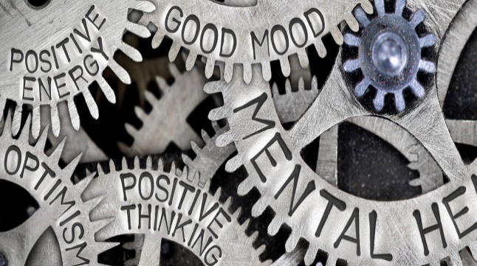
One in five adults in the United States experiences mental illness at some point in their lives, according to the National Alliance on Mental Illness (NAMI). Some of those you know and love likely cope with mental illness. You may not know it because they continue to work, perform, create, compete, laugh, love and inspire others every day—and they don’t talk about their mental health condition.
Why? Because the centuries-old stigma about mental illness persists. And because of stigma, millions of Americans silently suffer, unable to seek help for very common and treatable mental health conditions.
Studies show that a majority of U.S. citizens and many Western Europeans have negative attitudes about mental illness, many of which are worsened by film and media.
Why do we hold on to stigma, even when we know better?
Humans are social creatures and are hardwired to be a part of a social network. This is a part of our DNA. We are biologically programmed to care about what people think of us. If we think that something about us will isolate us from our social network, or tribe, we will do our best to hide this part of ourselves.
If we know why we have stigma, how can we change it?
We can all play a part in destigmatizing mental illness in our culture, so that more people seek support instead of suffering in silence. The National Alliance on Mental Illness (NAMI) suggests these proven strategies:
- Talk openly about mental health. The more we talk about it, the more we normalize it.
Tell your story when appropriate and if you are ready. If the thought of this makes you very uncomfortable, that is proof of the stigma that exists. Talking about your own struggles and experience with therapy or treatment can be a huge catalyst in helping others.
- Encourage equality between physical and mental illness.
We wouldn’t hesitate to get someone help if they were experiencing chest pain, we should also not hesitate if someone is experiencing mental illness.
- Also, don’t blame or shame yourself if you have a mental illness. Notice if self-talk becomes negative and address it. Talking with a therapist can help with this.
- Educate yourself and others through workshops, training and sharing well-researched articles from credible sources, like NAMI.
- Know the resources available to you, such as employee assistance programs and mental health services your health plan provides. Keep your list of resources handy and share them with family members and co-workers.

Shifting our mindset
"Sadly, too often, the stigma around mental health prevents people who need help from seeking it. But that simply doesn't make any sense," wrote former First Lady Michelle Obama in The Blog: Let's Change the Conversation around Mental Health. Whether it affects your heart, arm or brain, an illness is an illness, “and there shouldn't be any distinction."
When it comes to stigma, you can help. Sharing this article with a colleague or a loved one and having an open conversation about mental health is a great way to shed light on mental illness, which can strike anyone at any time.
For more ideas on how you can help change perceptions about mental health, read this article from the Mayo clinic.
ERS is hosting several webinars on topics related to mental health in the month of May with experts in the field. We encourage you and your families to tune in to learn more about how you can combat stigma and what your resources are when it comes to mental health. You can find all of the registration links at the ERS Wellness Events Calendar.
The mental health benefits available to you as an ERS health plan participant can be found through the ERS website, your health plan’s website, or by calling your health plan’s customer service center.
Information about mental health benefit changes during the COVID-19 pandemic, can be found at this link by scrolling down to “Emotional Support”:
https://www.ers.texas.gov/What-s-Happening-Now/COVID-19-and-Your-Health-Plan

