Social Media Posts to Promote Mental Health Awareness

1.
“Shift your Mindset” Facebook image

2.
Your mental health matters just as much as your physical health. Check out upcoming ERS webinars on topics that impact our mental health: managing relationships, financial fitness, and smashing the stigma around mental health conditions. [link to wellness events calendar, and make sure there is an image]
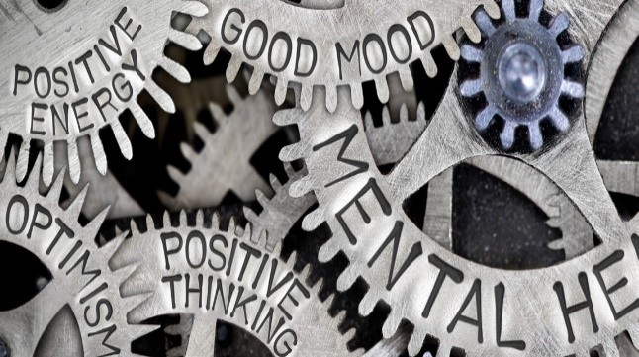

3.
Human connection is essential for our mental health. Here are some words of wisdom from one of the HealthSelect of Texas vendors, Naturally Slim’s Todd Whithorne.

