Financial Wellness Social Media Posts
- If you have money goals, you won't want to miss the August webinar series. Each week brings you a new topic -- from “Budgeting Basics” and “Credit 101” to “Ask a Financial Expert about Money Management” and “Funding your Future.”
Photo from Pixabay, free to use, no credits required.
https://pixabay.com/photos/money-coin-investment-business-2724241/

- Take a free financial health assessment and find resources to help you crush your money goals through Securian. Visit www.LifeBenefits.com/LFG (user name: lfg, password: resources)
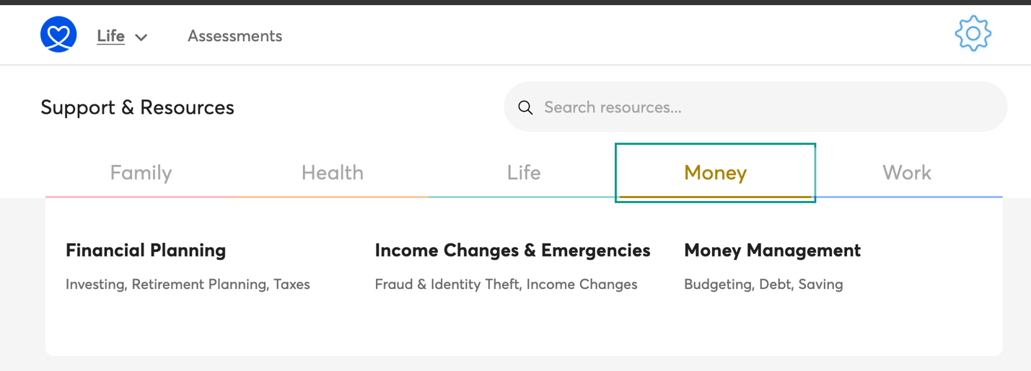

- Learn the basics of creating and managing a budget with the Budget Girl. Sarah is a young woman living right here in Texas who managed to pay down $33K in debt by age 29. https://www.youtube.com/watch?v=wyl063poExg

- Money makes more cents with these 8 financial tips! https://www.facebook.com/FirstMediaBlossom/videos/161172505297488/

- 40% of Americans would have difficulty covering an unexpected $400 expense. Don’t be one of them! Get inspired to create an emergency fund with this short video from @TheFinancialDiet https://www.youtube.com/watch?v=L3EwcjzHiqY

