July Social Media Posts
Social Media Post #1 (Note: This should be posted before July 7th)
If you think exercise is self-indulgent, think again! Learn how your fitness enhances your performance and leadership during a new July 9th webinar with Lieutenant Colonel (Retired) David Yebra, Division Director at TDCJ over Training and Leader Development titled “Fit to Lead.”. Registration links are available now in the ERS Wellness Events Calendar!
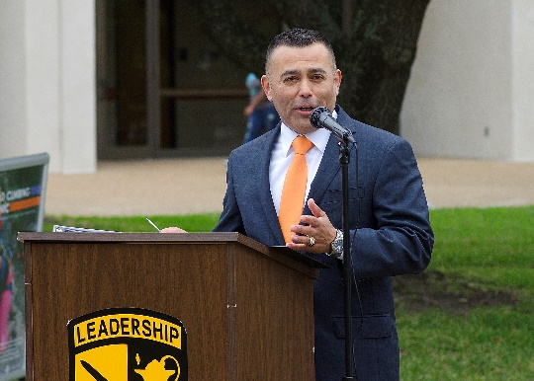

Social Media Post #2
Join ERS Health Promotion Administrator, Lacy Wolff, for a 10-minute Stretch Break at your desk!
https://www.youtube.com/watch?v=mozpiKLuHDU&feature=youtu.be

Social media Post #3 (NOTE: This should be posted before July 21st)
“Never Has Physical Activity Been More Important” – On July 23rd at 10 a.m., learn why and how from one of the country’s leading clinical thought leaders in exercise and obesity research, Dr. Tim Church, M.D., M.P.H, Ph.D. Register for this NEW webinar through this link.

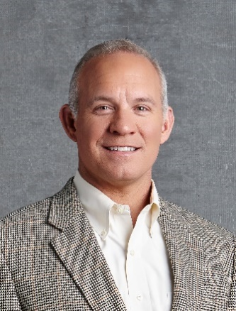

Social Media Post #4 from Move.org
Some mornings, you just don’t feel like working out. Here’s an idea: Try putting your sneakers right by your bed, so they’re the first thing you see. Check out @HHSHealthGov’s Move Your Way video for more tips to help you get moving: https://bit.ly/2JLPnNJ

