July Webinars
Fit to Lead with David Yebra
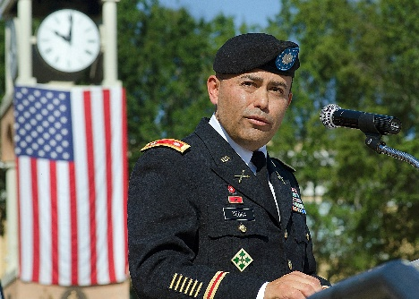
Growing up playing soccer, then later graduating from the U.S. Military Academy at West Point, Lieutenant Colonel (Retired) David Yebra has always made physical fitness part of his life. Now, as the Director of the Training and Leadership Development Division for Texas Department of Criminal Justice, Director Yebra believes exercise is never self-indulgent. Rather, it is necessary to maintain high levels of performance with the demands on today’s leaders. In this webinar, he will share the ways fitness contributes to effective leadership. In line with every airline’s advice to put your own oxygen mask on before helping others, Director Yebra will also give strategies for current and future leaders to stay more active and prioritize their own fitness, so they can take care of their employees..
Date: Thursday, July 9th
10 a.m. Registration Link
12 p.m. Registration Link

Overcoming Postural Issues & Exercise Form
Due to COVID-19 and our work in remote locations, we are using technology more than ever. Web meetings have taken the place of in person meetings. Email and phone calls have replaced conversations. All of these changes can lead to poor posture and even injury if not addressed. For example, cell phone and computer usage can cause what has been termed “tech neck” by physical therapists. Ergonomic challenges at home or in a car can cause posture imbalances. Adding exercise on top of these imbalances may cause more misalignment and lead to injury. In this webinar, you will learn exercise solutions to combat these issues and reminders of good form when exercising.
Date: Thursday, July 16, 2020
Registration links:
10:00 am Registration
12:00 pm Registration

Never Has Physical Activity Been More Important
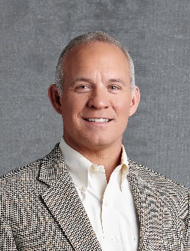
Social distancing doesn’t mean you have to say “so long” to staying active, especially when breaking a sweat is so darn good for our health. Dr. Tim Church, M.D., M.P.H, Ph.D., one of the country’s leading clinical thought leaders in exercise and obesity research, will share research on why breaking a sweat is so good. As author of more than 250 clinical articles, Dr. Church has received numerous awards for his research in preventive health. He has been cited as an expert source for preventive health stories by The New York Times, U.S. News & World Report, Reuters, Los Angeles Times and The Wall Street Journal.
Beyond the research, he will also share practical ways to exercise or be more physically active at home. With a near-empty social calendar, now’s a perfect time to start. Being physically active is proven to help reduce your risk of type 2 diabetes, cardiovascular disease, falling, and some cancers. It can also help you manage your weight, boost your mood, and even help you live longer!
Date: Thursday, July 23, 2020
Registration link:
10:00 am Registration
Pre- & Post-Workout Nutrition
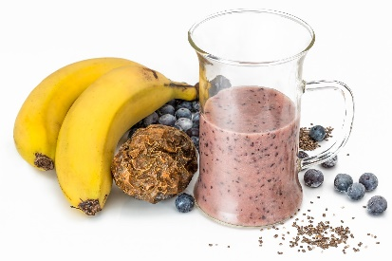
Getting the most out of a workout means being able to make it through the whole workout and work at a high intensity, in addition to quickly recovering. To achieve this, pre- and post- workout nutrition becomes crucial for optimal success, in addition to proper planning and programming.
This webinar will teach you optimal pre- and post- workout nutrition based on peer reviewed research. Using the right mix of nutrients and timing can help get the most out of a workout and help you reach strength, body composition, and even endurance goals.
Date: Thursday, July 30, 2020
Registration links:
10:00 am Registration
12:00 pm Registration

