Fit to Lead, featuring David Yebra
By Lacy Wolff, ERS Health Promotion Administrator

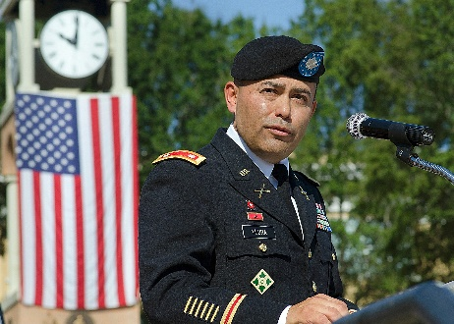
July’s wellness focus is on the benefits of physical activity. Lieutenant Colonel (Retired) David Yebra not only embraces physical activity as a lifestyle, he inspires others to do the same. A graduate of the U.S Military Academy at West Point, and Army veteran who served in Iraq, David currently serves as the Director of Training and Leader Development Division for the Texas Department of Criminal Justice, where his leadership style has motivated countless individuals to perform at their best. Director Yebra describes in the Q&A below how physical activity keeps him at his best, so he can continue to serve others. Mr. Yebra will be featured in an upcoming webinar on this topic on July 9th. I hope you will join us for this informative and inspirational webinar. Register through the ERS Wellness Events Calendar.

Why is physical activity important to you?
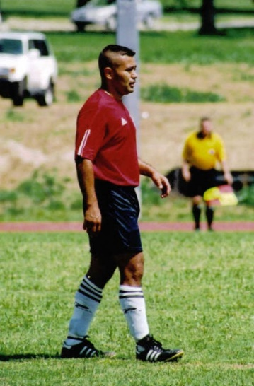
I strive to be at my best for my team. To do so, I need to be at my peak performance mentally, spiritually, and physically. When I am not active, I just don’t feel my best. After a morning run, my mind is clear and I’m in a much better frame of mind to deal with the challenges of the day. When it comes to making time, most will tell themselves, “I don’t have the time to work out,” then sit in the office in a less-than-productive state. A morning workout can help you save time because of your clarity of thought, creativity, and energy. Bottom line – you will be better at work and at home.
Where did your love of physical activity begin?
Like so many others, I grew up playing sports. We had an incredible soccer coach who taught us the value of hard work. He not only taught us how to fail, but he showed us how to win. He taught us how to believe in the power of mind over body. I also remember watching the Winter Olympics, especially the hockey and speed skating, then going outside on roller skates to replicate the competition. I still tap into that youthful spirit in order to motivate myself to exercise. Ask yourself, “what if I just didn’t know how old I was?” Would you still make the same decisions about being active? Most use age as a reason not to do something.
What types of physical activity do you enjoy?
There is nothing like a morning run to start the day. The breeze, watching the sun come up, the birds chirping – all help get me in the right frame of mind. I also love playing soccer in a recreation league. My teammates inspire me to stay fit and ready for the competition (they’re 10-15 years younger than me). The team feeling helps me get out the door when I don’t feel like running or working out. Committing to a team is a forcing function. Without it, I would not have the same level of desire to stay active.

Personally, how does your physical fitness level impact your mental resilience?
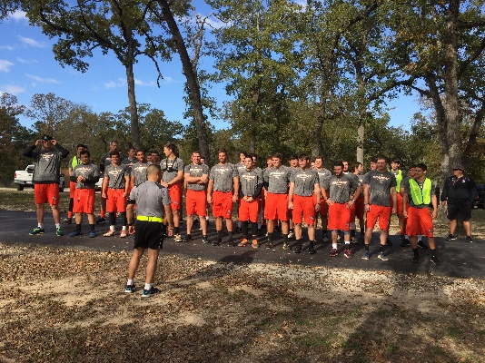
My ability to be at my best is directly linked to my level of physical fitness. I can definitely feel the difference when I haven’t been exercising. I didn’t realize how much until recent restrictions prevented us from playing soccer. I could feel myself becoming less and less effective as a leader. I was not as relaxed, smaller tasks seemed to get bigger, my reaction to stressful situations became more about emotion, and I was unable to really think clearly and to listen to my team. When I’m at my best physically, I feel as if I can see the world differently. I’m more vulnerable when my level of fitness is not where it should be. My mental resilience is dependent on my level of physical fitness. Even in Iraq as an Army officer, taking time to exercise was critical in dealing with the complexity of the life and death situations in combat.
If someone is not currently active, do you have recommendations for how to start?
Don’t overthink it. Just start doing something. It doesn’t have to be an elaborate workout with a title – just get out and let gravity help. Remember, 30 minutes a day is more than zero. Your ability to exercise in the morning starts with what you do the night before. Make it as easy as possible to get up and exercise. Sleep in your workout clothes with shoes and socks by the bed. Set the coffee pot to brew if you enjoy that in the morning. Tell others what you are doing to help keep you accountable – “they’re going to ask me about it.” Find a purpose for your exercise whether it’s a vacation, a team event, or a special occasion. I wasn’t a believer in apps to track exercise, but I found myself getting out the door because “I had to get 30 minutes in this week” to stay on track for an employee benefit. I listen to audiobooks and my workout time is the only quiet time I get to enjoy my book. Once you get over the “hump” and start to feel the benefit of being active, you’ll never want to go back. Document your experience with a journal and photos. There’s nothing like looking at how much progress you have made.
How does physical activity impact your ability to lead?
At West Point, I remember reading a quote from JFK displayed at the entrance to the gym, “physical fitness is the basis for all other forms of excellence.” My ability to be the best leader possible is inextricably linked to my level of fitness. More than ever, leaders must be able to demonstrate the ability to see “the battlefield” in this volatile, uncertain, complex, ambiguous (VUCA) environment we find ourselves in. To be at our best in this environment, we must “master ourselves before we seek to master others.” Douglas MacArthur shared that in his final speech to the Corps of Cadets at West Point in 1962, but his words still ring true. Physical activity helps us adapt to fluid and chaotic situations where others expect us to lead. Where managers thrive on creating certainty and predictability, leaders earn their “stripes” dealing with change, guiding their teams through these VUCA situations.
Join us for a live webinar titled “Fit to Lead” featuring Director Yebra on July 9th.
10 a.m. Registration Link
12 p.m. Registration Link

