Self-care
  - What it means and why we all need it
By Lacy Wolff
Self-Care is not self-indulgent or selfish. It is necessary to have good physical, emotional, and mental health. Have you ever been too busy to eat, or even go to the bathroom because you are taking care of work, your children, your parents, your home, etc.?
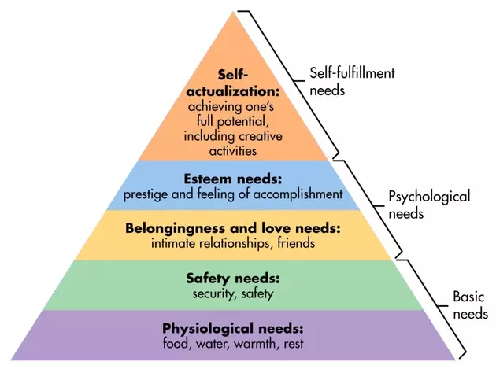
For every person, self-care can look different depending on what you enjoy and what matters most to you. I would like to connect the dots between self-care and Maslow’s Hierarchy of needs and show you how self-care is one of our most fundamental needs for survival and definitely not something to feel guilty about!
Abraham Maslow concluded that in order to meet our psychological needs and feel -fulfilled, we must first have our basic needs met including food, water, sleep, security, and safety. Remember how we forget to use the bathroom or eat, or sometimes forego sleep for something else that seems more important?
When we are hungry, scared, or haven’t slept, it is very difficult to think of anything else because of our psychology and physiology. This is one of the reasons why we work so hard to promote good sleep habits, nutrition, and financial fitness. These are all basic needs and are fundamental to our lives. It’s not just self-care, these things are essential to our survival.
After our basic needs are met, we are able to tend to our psychological needs, like building and maintaining relationships, and working toward personal or professional goals that make us feel accomplished.
As social creatures, we humans cannot thrive without a social support structure and a feeling of belonging. Researchers now recognize loneliness as an epidemic -- as damaging to our health as smoking 15 packs of cigarettes per day. When most of us think of self-care, we think of indulging in a bubble bath, reading a good book or meditating (all wonderful ways of practicing self-care by the way). But enjoying time with (or talking on the phone with) our friends and family members is also self-care that pays dividends toward our own well-being.
Self-actualization is at the top of Maslow’s pyramid and is reached when we feel we are achieving our full potential, including like enjoying games and having fun. We can also find this state through creative activities – whether it’s cooking a healthy meal or finding the perfect birthday card to send creative activities. I don’t know very many people who have reached this state, but I believe this is where we can really find joy in our lives, by engaging in activities that make us truly happy.
If you were to give someone an instruction manual for you, what would it say? What do you need to be at your best? List at least three things. Then ask yourself, “If I were doing these things every day, how would my life be different?” Self-care is more than a concept, it is a mindset.
We have three webinars this month that will help reinforce these concepts. I hope you will join us!
You can get more details through the ERS Wellness Events Calendar. As always, please let me know if you have any questions regarding your wellness benefits at wellness@ers.texas.gov

