October Social Media Posts

Social Media Post #1

Join in for a free webinar on October 8th, from 10-11 a.m. CST focusing on Coping Strategies to Build Resilience, featuring Clinical Psychologist Kevin Gilliland, Ph.D. Register through this link.

Social Media Post #2

What we eat can impact our hormones and our mood. Learn ways to help balance your hormones through nutrition in this new webinar Feel Good Food: Nutrition to Bolster Immunity hosted by Texas DPS. Registration link can be found at the ERS Wellness Events Calendar.
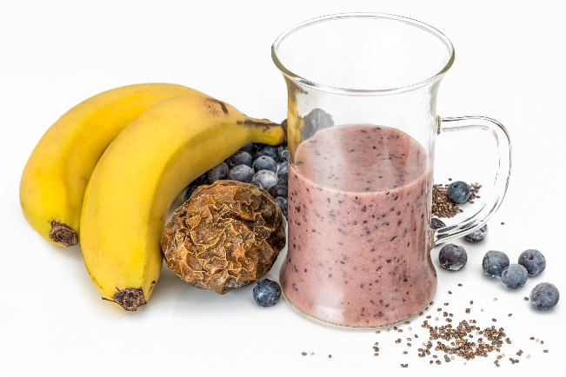

Social Media Post #3

We are often kind to others, but can be incredibly hard on ourselves! On October 22nd at 10 a.m., Lacy Wolff of ERS will delve into the science of self-compassion and will demonstrate evidence-based skills for building your resilience in this new free webinar, Building Resilience through Self-Compassion. Register through this link.

