May Social Media Posts

Social Media Post #1

You are not alone! Join ERS this as we focus on Mental Health Awareness. Learn ways to build resilience and how to access your mental health resources before you need them. Check out the ERS Wellness Events Calendar for full event details and registration links. https://ers.texas.gov/Event-Calendars/Wellness-Events

Social Media Post #2
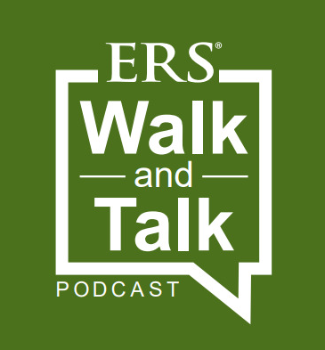

Text: Join us on a 20-30 minute walk while we talk about health, wellness, and life in general. From the Employees Retirement System of Texas, podcast host Lacy Wolff walks and talks with her mentors, friends, experts and leaders about health and wellness.
https://erswalkandtalk.buzzsprout.com/

Social Media Post #3

On May 20th from 10-11 a.m. join us as we explore ways to Fight Back against the Loneliness Epidemic through a new webinar featuring Megan Humphrey and Alesa McDonald of Texas DPS. We will discuss what it means to establish meaningful connections and how to do this as we emerge from a global pandemic. Learn more and register through this link: https://attendee.gotowebinar.com/register/5620709353261704204

Social Media Post #4

Build your mental health toolkit on May 27th from 10-11 a.m. Be prepared with a better understanding of the mental health treatment options available to you and your family members enrolled in the HealthSelect of Texas® or Consumer Directed HealthSelectSM plans. Register through this link: https://attendee.gotowebinar.com/register/8714118247866876176
Mental health

Share text: If you struggle with mental health issues, you’re not alone. One in five U.S. adults experience mental illness. During Mental Health Awareness Month take advantage of your HealthSelectSM coverage, which includes access to emotional support and mental health benefits. Your plan covers both inpatient and outpatient treatment, including Virtual Visits.

[Link to mental health page: https://healthselect.bcbstx.com/content/medical-benefits/mental-health]

