April 2023 Newsletter Content: Focus on Stress (management)

Stress impacts us all in different ways. This month we will explore ways to self-regulate and take charge of your emotional states and physiology to effectively manage stress.

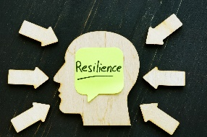
Build Resilience and Manage your Stress. Join Lacy Wolff from ERS and Becky Gillespie from BlueCross and BlueShield of Texas on April 13th from 10-11 a.m. CST for a 60-minute webinar on strategies to be more resilient and aware of how stress impacts health. In this webinar we will discuss stress, what it is and how it impacts us (positively and negatively, how our mindsets and beliefs about stress benefit our health, and 3 simple strategies to improve our response to stress and build resilience. Register through this link.

Practice yoga with Chris Young, Ph.D. from Texas Department of Transportation and learn strategies for self-regulation through yoga. Class is offered every Wednesday in April from 10-10:30 a.m. via Zoom. This class is suitable for all ﬁtness levels. For full details and links to join virtual ﬁtness classes, check out the Virtual Fitness Calendar page.

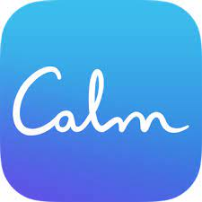
Find Calm. Discover the power of Calm – the #1 app for sleep, meditation and relaxation. Join the millions experiencing better sleep, lower stress and less anxiety with guided meditations, an entire library full of Sleep Stories, expansive breathing programs, gentle stretching exercises and exclusive music tracks for relaxation and focus. Purchase a 1-year subscription for $14.99 (save 78%) through the ERS Discount Purchase Program. Offer available through 4/19/2023.

Connect. The wellness team at BlueCross and BlueShield of Texas offers monthly Fitness and Nutrition Connect Community Calls. This month the focus of these connection opportunities is “Stress Management” through Fitness and Nutrition. Learn more and register for events through the ERS Wellness Events Calendar.

