April 2023 Social Media Posts
  - Social Media Post #1:
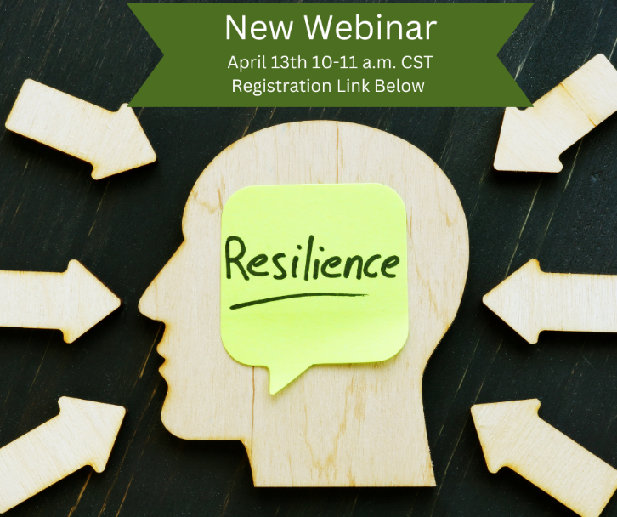

Share text: Learn strategies to Build Resilience and Manage Stress with Lacy Wolff, MS from ERS. Learn more and register through this link: https://attendee.gotowebinar.com/register/7336741355161149019
Social Media Post #2
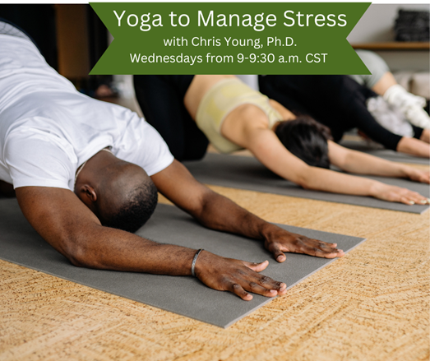
Share text: Learn how yoga can be a tool to manage stress in this month’s 4-part series on Yoga to Manage Stress with Chris Young, Ph.D. from TxDOT. Classes will be held every Wednesday from 9-9:30 a.m. via Zoom. Learn more through the Virtual Wellness Calendar: http://wellness.texas.gov/Challenge.htm

Social Media Post #3:
Join us for the 2023 Awards Ceremony webcast to see who is taking home the trophies this year. This webcast will kick off with a few words from Statewide Wellness Coordinator, Lesley Jimenez from DSHS and will wrap up with the announcements of our winners!
Register through this link: https://attendee.gotowebinar.com/register/5023499732163626840

