June Social Media Posts
Social Media Post #1:
Are you getting ready to go back to the office? If you’re not sure, connect with us through a new webinar, Re-entering the Workplace with Grace, on Friday, June 4th at 10 a.m. as we discuss the challenges of re-entering the workplace and healthy strategies to adapt to change. Register through this link:
Registration (gotowebinar.com)

Social Media Post #2:
Join Mike Harper of Texas DPS as he discusses 3 Simple Steps to Improve Men’s Health on June 17th from 10-11 a.m. Men are more at risk than women of an early death from leading (and preventable) causes, like heart disease and diabetes. The good news is that there are simple steps men can take to help improve their health today! Register through this link: https://texasdps.webex.com/texasdps/k2/j.php?MTID=t0dffcd7ccfaa0662b8252eb2160d9068

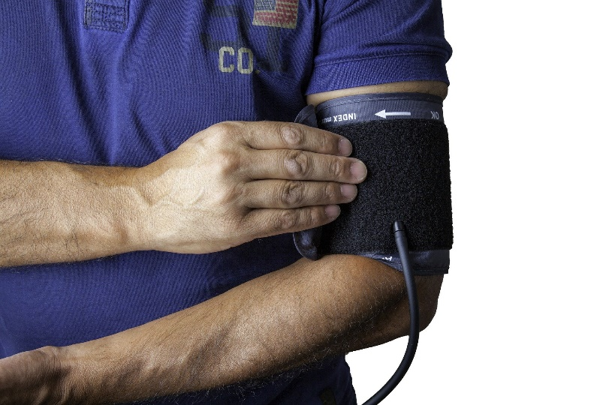

Social Media Post #3:
June is Great Outdoors Month! On June 24th from 1-2 p.m. we will hear about the health benefits of the outdoors and all the great things the Texas State Parks have to offer in our webinar featuring the Director of our Texas State Parks, Rodney Franklin. Learn more and register through this link: https://attendee.gotowebinar.com/register/8459680262284990222

