16306 TPA 2301-06 March 2023 social media posts

Health Assessment

Share text: Looking for new insight into your health? The online Health Assessment in Well onTarget® can provide health and wellness recommendations to help you set personalized long-term goals. Plus, you’ll earn 2,500 Blue PointsSM!

[Link to Health Assessment page: https://healthselect.bcbstx.com/health-and-wellness-incentives/health-assessment]

Nutrition Connect Community

Share Text: March is National Nutrition Month! Join BCBSTX for online Nutrition Connect Community sessions to connect with other participants, share your experiences and learn how to incorporate foods into your daily routine to support your optimal health.

[Link to upcoming webinars page: https://healthselect.bcbstx.com/publications-and-forms/healthselect-webinars]

Weight management

Share text: With WondrTM or Real Appeal®, you can get the support you need to manage your weight. Both programs are available at no additional cost for eligible HealthSelectSM medical plan participants.

[Link to: https://healthselect.bcbstx.com/health-and-wellness-incentives/weight-management-programs]
Well onTarget nutrition resources

Share text: It’s National Nutrition Month! From one-on-one coaching to self-directed educational programs, Well onTarget® has nutrition-focused resources to help you reach your wellness goals your way.

[Link to: https://healthselect.bcbstx.com/health-and-wellness-incentives/portal]

Fitness Connect Community

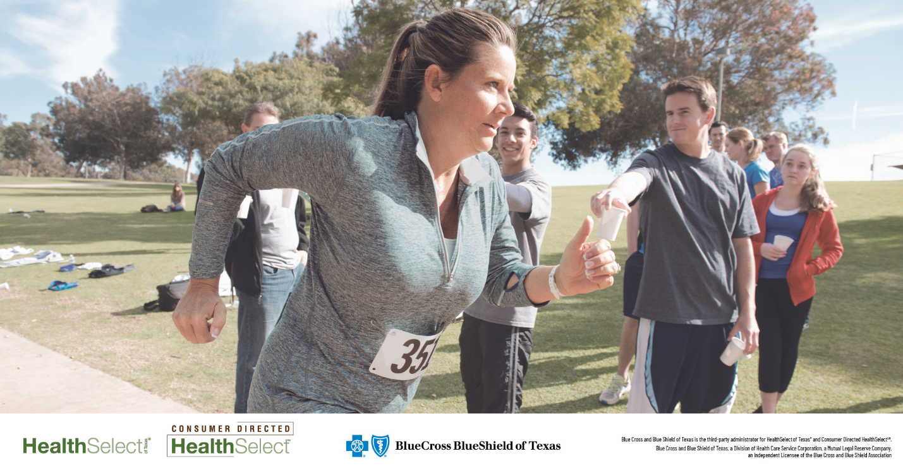

Share text: You’re invited to join the Fitness Connect Community! The monthly online sessions feature discussions with Blue Cross and Blue Shield of Texas wellness consultants to help you stay physically active and healthy throughout the year.

[Link to Cvent registration site: https://cvent.me/P0AOoD]

