Nutrition: What is a healthy lifestyle and how do we get one?

By Lacy Wolff, ERS Health Promotion Administrator

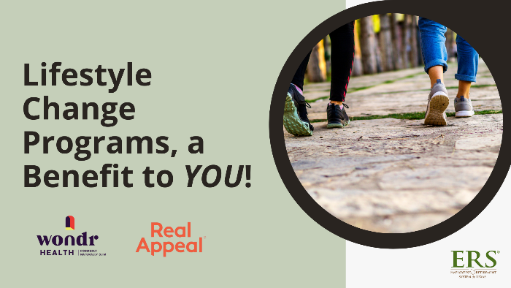
You’ve probably heard the phrase “it has to be a lifestyle change” from a doctor, dietitian, fitness or mental health professional. But what does that really mean? And, how can we change our lifestyle in a meaningful way?
Lifestyle, or the way we live, is a combination of our environment, our decisions, and the thousands of habits that drive our actions each day. The way we eat, the things we purchase, the way we move (or don’t), and the people we work and live with all influence our lifestyle, which is why improving our health can be complicated and challenging.
For example, processed foods high in sugar, salt and fat are addictive and easily accessible, making nutrition one of the most challenging aspects of health. And at any given time, about a third of Americans are on a “diet.”
“Just by following the tips and suggestions and the skills that Wondr Health has given us, I’m down 20 pounds in almost five and half weeks. The skill sets that Wondr Health gives you are lifelong skills that will make a difference in your life and your health.” – Lisa, TDCJ
Unfortunately, dieting simply doesn’t work for most people. According to a study published in 2020 that looked at 14 popular diets with close to 22,000 participants, people lost weight and improved their heart health in the first six months, but the weight-loss and health benefits tended to disappear at 12 months.
Rather than following tips and tricks for how to change your nutrition, consider a lifestyle program (not diet!) that is scientifically proven to help people lose excess weight. Two programs are available at no cost to you if you are a HealthSelect plan participant: Wondr Health and Real Appeal.
These programs have worked for countless people and (if you are interested and ready) can help support you, too.
Which program is right for me?
Wondr Health is a virtual program that focuses on changing eating and other lifestyle habits. If accepted to the program you will receive a welcome kit of useful tools and can start watching the self-paced, personalized videos and engage with the online Wondr community. Wondr skills are taught in the first 12 weeks and reinforced during the second 12 weeks. Participants can enroll and engage in the Wondr program for up to one year.
Real Appeal is a virtual 52-week program that includes a weekly group coaching session and focuses on personalized, small steps each week to achieve your weight loss goals. Participants who enroll in Real Appeal receive a welcome kit of useful tools and can connect to their personal coach throughout their experience.
Eligibility Requirements
You are eligible if you are:
- an employee, retiree or dependent enrolled in a HealthSelect plan (excluding Medicare-primary participants),
- 18 or older and
- have a BMI of 23 or higher. Calculate your BMI through this BMI calculator.

