May Newsletter Article: The Power of Vulnerability
By Lacy Wolff, MS
Whenever I’m not feeling well, I sometimes have the bad habit of Googling my symptoms. When the list of possible conditions I might have pops up on the screen, I can feel anxiety build. My heart starts to race and my blood pressure begins to rise. I try to calm myself down, but I always end up fearful of the diagnosis I get from my search. Could it be something serious?
Vulnerability is the birthplace of love, belonging, joy, courage, empathy, and creativity. It is the source of hope, empathy, accountability, and authenticity.
– Brene Brown, Ph.D.
Do you do this too? Can you relate? Does the fact that I shared this about myself help you to feel supported and know that you are not alone?
Most likely, the majority of people can relate to this experience. Knowing that other people share the same experiences feels comforting. When we talk about it, we are normalizing the behavior and connecting with others.
What I shared with you about looking up my symptoms online requires me to be vulnerable.
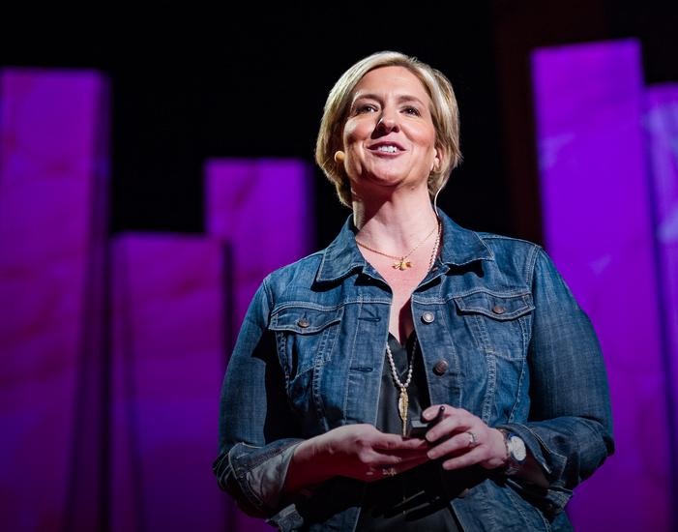
Brene Brown, Ph.D. is a qualitative researcher and professor at the University of Houston that studies complex emotions including shame and vulnerability. In her 2011 TED Talk, viewed over 67 million times, states that, “vulnerability is the birthplace of love, belonging, joy, courage, empathy, and creativity. It is the source of hope, empathy, accountability, and authenticity.” AND…she also describes the feeling of vulnerability as “uncertainty, risk, and emotional exposure
We (humans) are not wired to lean into these feelings. We are social creatures that have evolved to live in tribes to protect each other from predators and danger. Anything that makes us feel like we are “outsiders” from our group is very unsettling and makes us feel unprotected (vulnerable to attack) by our own tribe, or predators beyond. Most of us don’t live in tribes anymore, but our brains still have these mechanisms built in for protection, no different from our fight, flight, or freeze response to perceived danger. Sharing an uncomfortable feeling, anxiety or fear feels risky, in part because of the stigma in our culture around mental health.
Photo Credit: https://www.ted.com/speakers/brene_brown
The stigma, is often subconscious…We have been conditioned through movies and in our language to classify people with mental health diagnoses as “crazy” or violent. Mental health conditions are normal and as much a part of being human as a physical injury or chronic condition, like hypertension. According to the National Alliance on Mental Illness, (NAMI), one in five people will experience a mental health condition in their lifetime and that is nothing to be ashamed of!

You don’t need to stand up on stage and tell everyone that you are having a mental health crisis or are living with a mental health condition. But simply telling one person you trust, or a licensed counselor or social worker can help normalize feelings of shame, provide some comfort, a feeling of connection and a path to recovery. In other words, by sharing your feelings with a person you trust or a mental health provider, you are taking the steps to build a stronger connection.

During May we will be providing opportunities to connect and explore topics related to mental health so we can all help to improve our workplace cultures across the state. Learn more and register through the ERS Wellness Events Calendar.

If you are suffering with a mental health condition and need support you have access to a network of mental health providers through HealthSelect of Texas that you can visit in-person or virtually.

