May 2022 Social Media Posts

- Happiness at work matters! Learn more in our new podcast episode featuring Raj Raghunathan, Ph.D. from the University of Texas business school.
Link to episode: https://www.buzzsprout.com/1566635/10499052

Optional Photos to input:

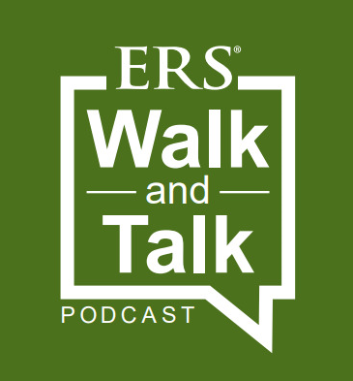

- Your mental health MATTERS as much as your physical health. Check out upcoming ERS webinars on topics that impact our mental health: [link to wellness events calendar, and make sure there is an image]

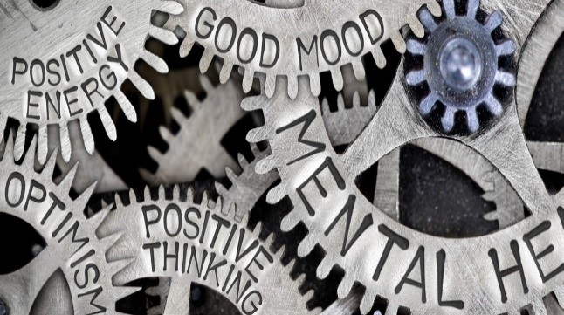
- Movement is good for your brain! Check out the new FREE online state employee virtual fitness calendar and get a workout in with other state employees across the state during your lunch hour! Embed Link: Work Well Texas – Everything’s Fitter In Texas! (state.tx.us)

