May 2023 Social Media Posts
Mental Health Awareness
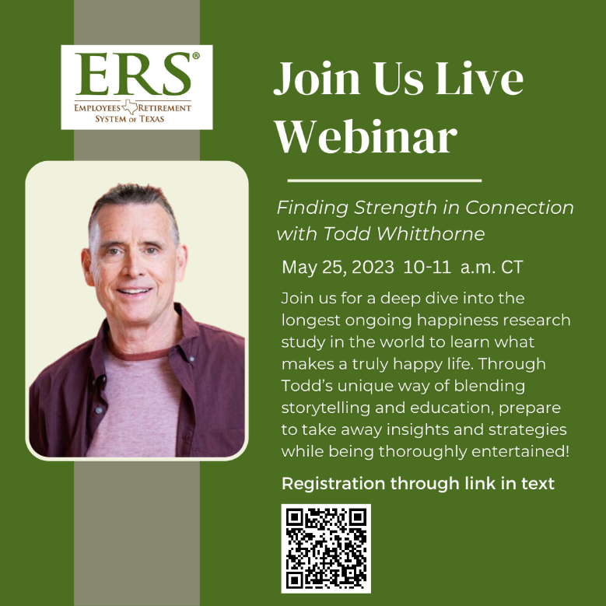
Share Text: Registration Link: https://attendee.gotowebinar.com/register/8915532301374968664

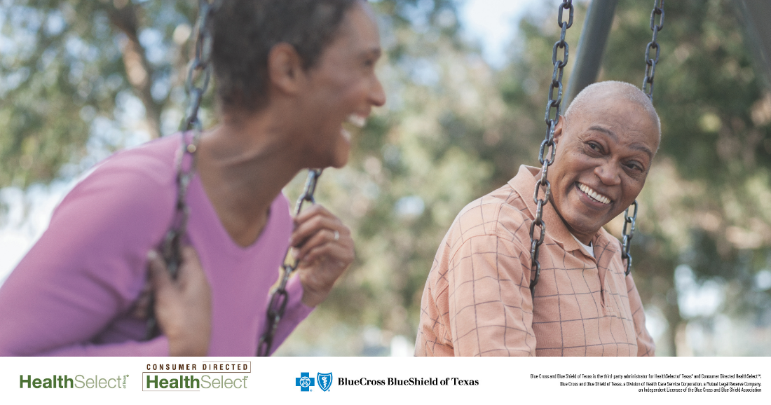
Share text: If you struggle with mental health, you’re not alone. One in five adults in the U.S. experience mental illness. During Mental Health Awareness Month, take advantage of your HealthSelectSM medical plan benefits, which include access to emotional support and mental health services. Your plan covers inpatient and outpatient treatment, including Virtual Visits, from the comfort of your home or office.
[Link to mental health page: https://healthselect.bcbstx.com/medical-benefits/mental-health]

Mental health Virtual Visits
Share text: May is Mental Health Awareness Month. Did you know that most HealthSelectSM medical plans include access to no-cost mental health Virtual Visits through MDLIVE® and Doctor On Demand®? Consumer Directed HealthSelectSM participants pay 20% after meeting the annual deductible.
[Link to Virtual Visits page: https://healthselect.bcbstx.com/content/medical-benefits/virtual-visits]

Women’s Health Month
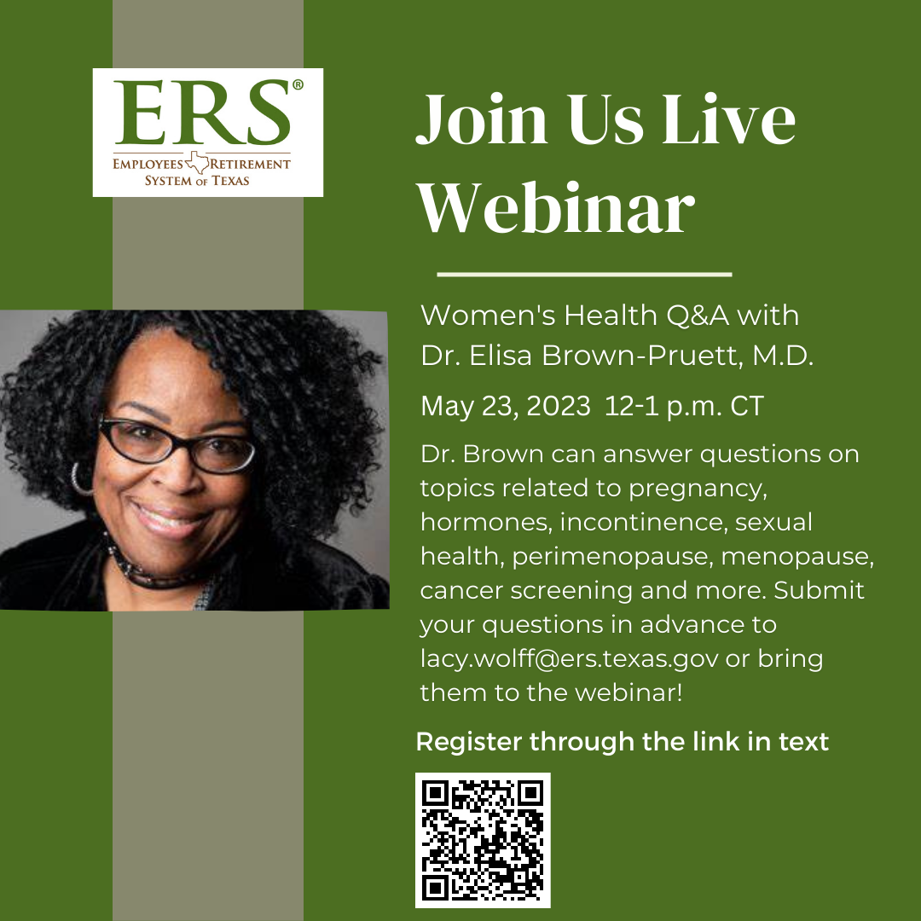
Share Text: Registration link: https://attendee.gotowebinar.com/register/1231645868350717016

Share text: May is Women’s Health Month. This is a great time to make sure you’re taking care of yourself. Your HealthSelectSM medical plan covers preventive care, including annual well-woman exams and preventive screenings like mammograms and colonoscopies, at no cost to you.
[Link to: https://healthselect.bcbstx.com/content/medical-benefits/preventive-care]

Nutrition Connect Community
Share Text: The foods you eat play a role in your cognitive function and contribute to your mood and sense of well-being. Join BCBSTX for May 23 online Nutrition Connect Community session to learn more about the food and mind connection, connect with other participants and share your experiences.
[Link to upcoming webinars page: https://healthselect.bcbstx.com/publications-and-forms/healthselect-webinars]

Fitness Connect Community
Share Text: You’re invited to join the May 9 Fitness Connect Community to learn how good mental health can positively affect your physical health. The monthly online sessions feature discussions with Blue Cross and Blue Shield of Texas wellness consultants to help you stay physically active and mentally healthy throughout the year.
[Link to upcoming webinars page: https://healthselect.bcbstx.com/publications-and-forms/healthselect-webinars]

