August 2023 Newsletter Content:

Financial Fitness

Are you wondering how you can maximize your 5% raise? Learn about financial planning tools and calculators to prepare for your future. Through the Texa$aver 401K/457 plan website and mobile application you can also setup an appointment to speak with an Empower Financial Representative at no-cost to you. Learn more about this benefit through this helpful video.

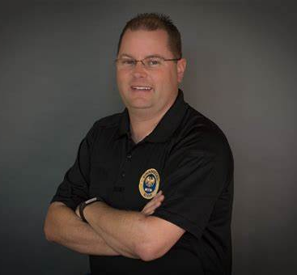
Join us August 17 from 10-11 a.m. CT to hear the inspiring story of Nick Daugherty. Nick paid off over $80,000 in consumer debt in two years using simple strategies and hard work. In this 60-minute webinar Nick will cover his personal story of falling into debt, how he clawed his way out, common financial pitfalls, and his own program that helps people create a proven plan to build financial strength. The program, “The eight phases of financial training” will help people in debt achieve financial freedom.
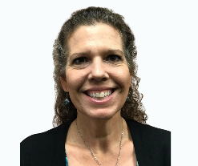
On August 24 from 10-11 a.m. CT, join Patricia Hord, MBA from the Office of the Consumer Credit Commissioner. Patricia will share strategies to help you get your finances on track by providing information on budgeting (types and tools), how to build a money mindset and strategies for success, including flexibility, goals and personalization!

Fitness & Nutrition Connect Community Calls Join the BCBSTX wellness team for 15-minute check-ins to connect with others and engage in a lively wellness discussion on topics related to nutrition, fitness and finances! Check out the full schedule of events and register for sessions through the ERS Wellness Events Calendar.

Sign up to be a part of “More Health, More Wealth,” the 4-week financial wellness campaign starting Sept. 18. This program is designed to help you take control of your health and finances at the same time. Over the course of four weeks, we'll guide you through practical strategies to improve your well-being while saving money. Information will be sent to you via email, text or both!

