August 2023 social media posts

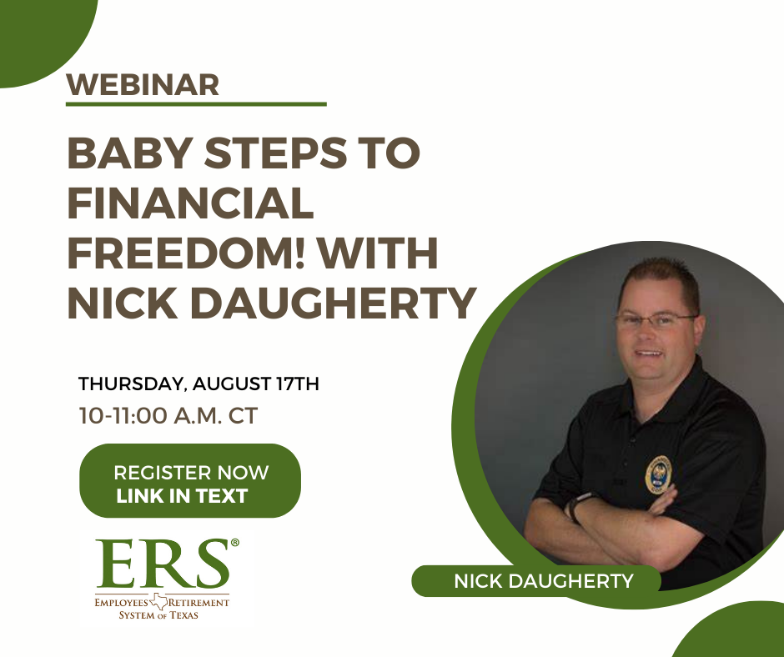
Insert Text: Join us August 17 from 10-11 a.m. CT to hear the inspiring story of Nick Daugherty. Nick paid off over $80,000 in consumer debt in two years using simple strategies and hard work: https://register.gotowebinar.com/register/7893127227103536983
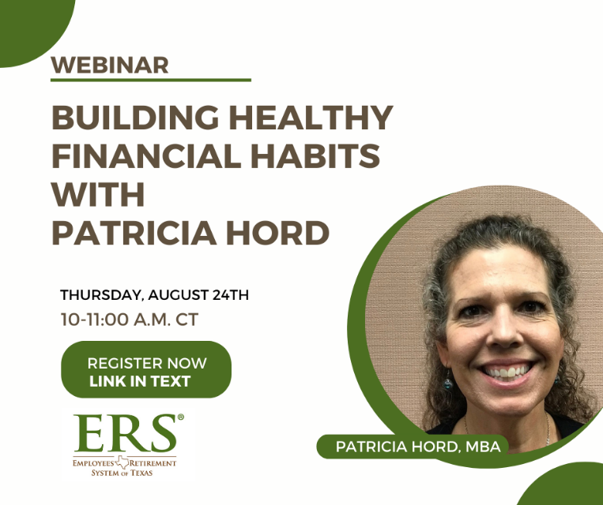

Insert Text: Join us August 24th from 10-11 a.m. to learn strategies to build healthy financial habits with Patricia Hord, MBA from the Office of Consumer Credit Commissioner. Patricia will share strategies to help you get your finances on track by providing information on budgeting (types and tools), how to build a money mindset and strategies for success, including flexibility, goals and personalization! Registration link: https://register.gotowebinar.com/register/5827434049922175323

Back to school preventive care
Share text: As summer break comes to an end, make sure your kids have all their recommended and required preventive care, including immunizations, before school starts again. HealthSelectSM medical plans cover most preventive screenings and services with no out-of-pocket costs when you visit an in-network provider.
[Link to preventive care page: https://healthselect.bcbstx.com/medical-benefits/preventive-care]

Options for Care
Share text: Where do you go when you have a routine or urgent medical situation that’s not life threatening? As a HealthSelectSM medical plan participant, you have many in-network options for care. Knowing your options and deciding where to go can make a big difference in how much you pay. If you have questions, call a BCBSTX Personal Health Assistant toll-free at (800) 252-8039 (TTY: 711), Monday – Friday 7 a.m. – 7 p.m. and Saturday 7 a.m. – 3 p.m. CT.

[Link to Options for Care page: https://healthselect.bcbstx.com/find-a-doctor-hospital/options-for-care]

Health Assessment

Share text: Looking for additional insight into your health? The online Health Assessment in Well onTarget® can provide health and wellness recommendations to help you set personalized long-term goals. You’ll earn 2,500 Blue PointsSM just for completing the online Health Assessment.

[Link to Health Assessment page: https://healthselect.bcbstx.com/health-and-wellness-incentives/health-assessment]

Care Management
Share text: Managing your health concerns and knowing where to go for care can feel overwhelming, but you don’t have to do it on your own. The care management program is a team of dedicated, Texas-based clinicians who can answer your questions to help you understand your new diagnosis and manage your health condition.

[Link to: https://healthselect.bcbstx.com/medical-benefits/care-management-programs]

Participant webinars
Share text: Whether you're interested in fitness, nutrition or learning more about your HealthSelectSM medical benefits, there's a webinar to help you get and stay healthy! In September, you’ll learn how to access your medical benefits information though Blue Access for MembersSM.
[Link to webinars page: https://healthselect.bcbstx.com/publications-and-forms/healthselect-webinars]

