December 2023 Newsletter Content:

Creating an Attitude of Gratitude

As 2023 comes to a close, we are focusing on being grateful for what we have and preparing to welcome a new year.

All about Gratitude:
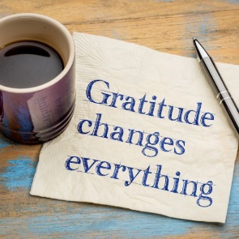
Attend a webinar: Gratitude: Science & Practical Application Join Lacy Wolff and Jewell Smith December 7, 10-11 a.m. CT, to learn how gratitude affects your brain and ways to integrate it into your daily life. Register through the Gratitude Webinar Registration link.
Join a challenge: Join the 3rd annual 5-Day Gratitude Challenge taking place from December 11-15 from 9-9:15 a.m. CT daily via Zoom. Sign up through the registration link
Read an article: (<3 min read) Your Guide for starting a Daily Gratitude Practice learn what a gratitude practice is, why it works and simple strategies to build one. Link to the article.
Download the the journal: Download the fillable weekly gratitude journal and start using it today.

More well-being opportunities:
WEBINAR: Mental Health during the Holidays: Join us for a webinar featuring Dana Haulotte of Texas Legislative Council on December 14th from 10-11 a.m. as she discusses mental health, mental illness (and the stigma that surrounds it), stress that comes with the holiday season and practical tips to manage it. Sign up through the registration link.

DAILY FITNESS & WELLNESS: Keep moving during December for free! Join encouraging fitness and mindfulness sessions featuring fitness instructors who are also state employees. The Work Well Texas Virtual Fitness offerings are week-day sessions that keep us moving TOGETHER! Check out the full calendar of events to join via Zoom from anywhere.

