December 2023 social media posts

Holiday mental health
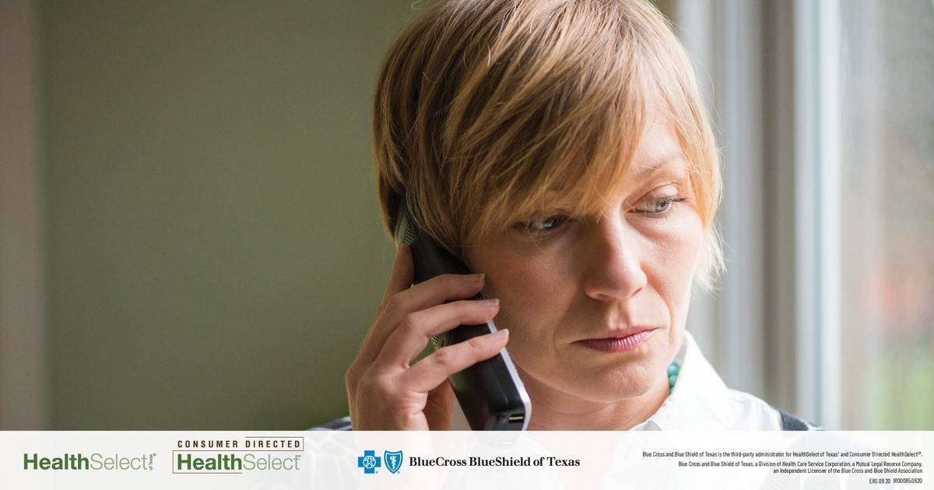
Share text: The holidays can be stressful. Your HealthSelectSM medical plan includes access to emotional support and mental health care resources to help you enjoy the season. All HealthSelect plans cover both inpatient and outpatient treatment, including Virtual Visits through Doctor On Demand® and MDLIVE®.

[Link to mental health page: https://healthselect.bcbstx.com/medical-benefits/mental-health.]

Virtual Visits

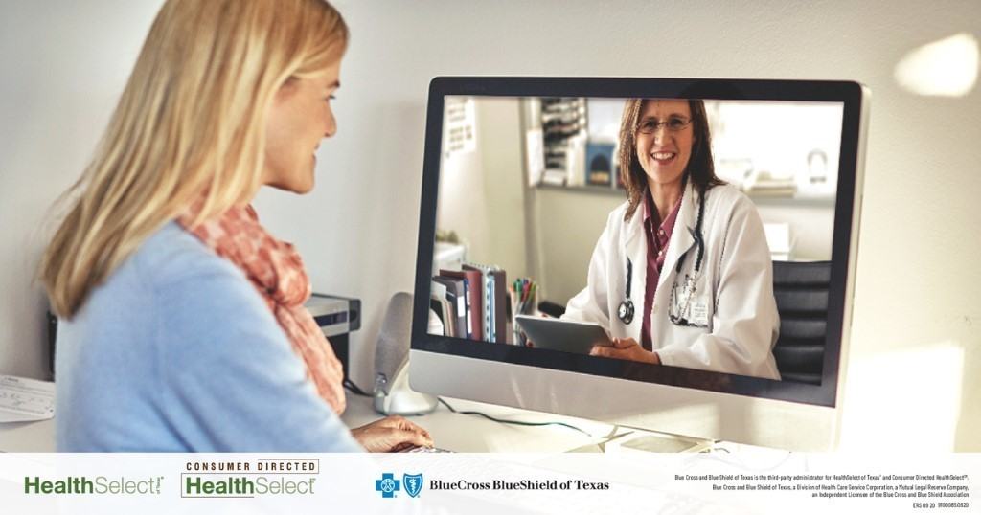
Share text: As a convenient alternative to in-person office visits, HealthSelectSM medical plan participants have access to medical and mental health Virtual Visits through Doctor On Demand® and MDLIVE®. Virtual Visits allow you to see a licensed mental health provider online or by phone from the comfort of your home or office.

[Link to: https://healthselect.bcbstx.com/medical-benefits/virtual-visits]

Take your Health Assessment
Health Assessment

Share text: Evaluating your current health is a great first step to maintaining a healthy lifestyle. The online Health Assessment in Well onTarget® can provide health and wellness recommendations to help you set personalized long-term goals. Plus, you’ll earn 2,500 Blue PointsSM!

[Link to Health Assessment page: https://healthselect.bcbstx.com/content/health-and-wellness-incentives/health-assessment]

Spend your Blue Points

Share text: Are you earning Blue PointsSM for doing healthy activities? You can redeem up to 17,325 points each calendar year for a wide variety of items including fitness gear, kitchen gadgets and camping equipment. Be sure to spend your points before the end of the year!

[Link to Blue Points page: https://healthselect.bcbstx.com/health-and-wellness-incentives/blue-points]

Care while traveling
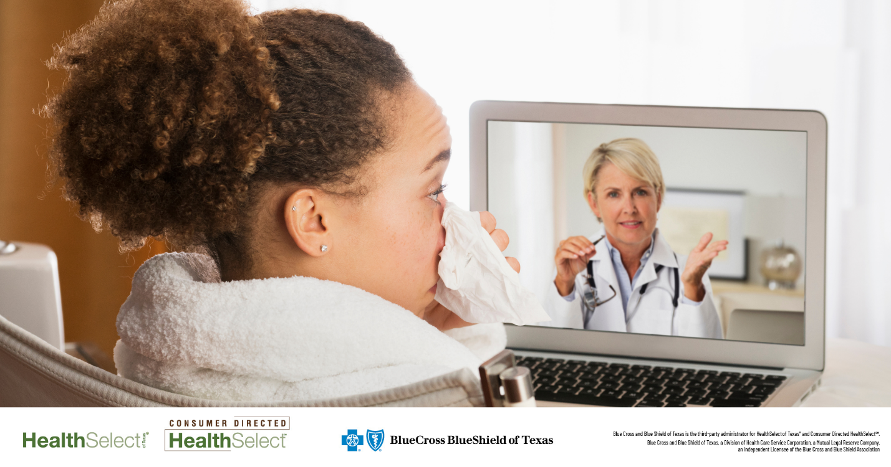
Share text: Traveling for the holidays? Whether you’re going near or far, your HealthSelectSM medical plan benefits have you covered.

[Link to Care While Traveling page: https://healthselect.bcbstx.com/find-a-doctor-hospital/care-while-traveling]

