December Social Media Posts
Share Text: Join us for an informative and interactive webinar where we explore Gratitude: Science and Practical Application. Learn how to put this simple and effective resilience skill to work for you, your family, and your workplace. Register through this link: https://register.gotowebinar.com/register/8068619164680167694

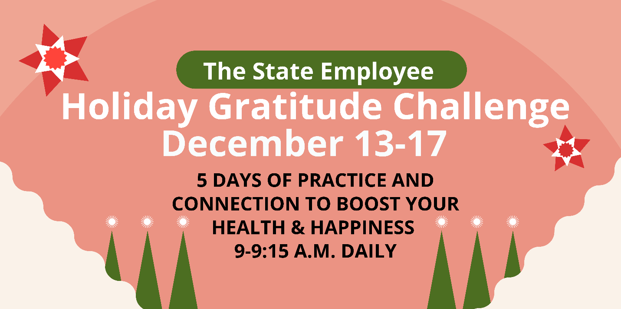

Share Text: Join the December Gratitude Challenge! Each morning we will connect over Zoom to learn and practice gratitude in a variety of ways with inspirational speakers. Register to receive daily updates and links through here: https://www.eventbrite.com/e/5-day-gratitude-challenge-tickets-203309432987

Share text: Are you earning Blue PointsSM for your healthy habits? You can redeem up to 17,325 points each calendar year for a wide variety of items including fitness gear, kitchen gadgets and camping equipment. Don’t miss out on your 2021 redemption!

[Link to Blue Points page: https://healthselect.bcbstx.com/content/health-and-wellness-incentives/blue-points]

Health Assessment

Got 15 minutes to spare for your good health? Take your online Health Assessment through Well onTarget® and get health and wellness recommendations to help you establish personalized long-term goals. Plus, you’ll earn 2,500 Blue PointsSM.

[Link to Health Assessment page: https://healthselect.bcbstx.com/content/health-and-wellness-incentives/health-assessment]

Holiday mental health
Share text: The holidays can be stressful. Your HealthSelectSM coverage includes access to emotional support and mental health care. Your plan covers both inpatient and outpatient treatment, including Virtual Visits though Doctor On Demand and MDLIVE.
[Link to mental health page: https://healthselect.bcbstx.com/content/medical-benefits/virtual-visits.]
Preventive check-ups

Share text: Start Strong in 2022 by getting your annual wellness check-up. All HealthSelectSM plans cover annual wellness check-ups and most routine preventive care at 100% when you see an in-network provider. This means you pay nothing out of pocket. Contact your PCP today to schedule an annual wellness check-up for you and your covered dependents!

[Link to preventive care page: https://healthselect.bcbstx.com/content/medical-benefits/preventive-care.]

