January 2021 Social Media Posts
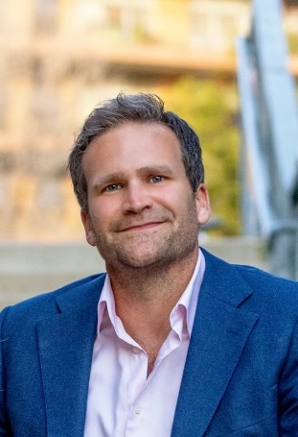
Post #1
“It’s Time Y’all!” Join us for an inspirational talk with Baker Harrell, Ph.D. and get your 2021 off to a good start! On January 7 at 10 a.m. Baker will help you connect the dots between your “why,” and your current health behavior with a presentation that blends humor, storytelling, and strategic action ideas to promote growth and positive change.
Registration Link

Post #2
Forget resolutions. Learn how to change your habits for lasting change, instead! Join Lacy Wolff on January 14 at 9:30 a.m. for “1 Degree of Difference” to learn more about strategies that work. Register for this webinar now through the ERS Wellness Events Calendar.

Post #3
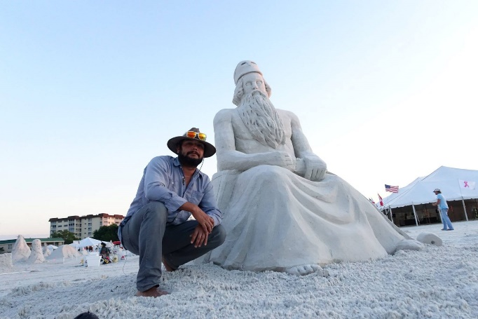
Go with the flow! Join us for “Flow: Strategies to optimize performance and build resilience” on January 21 at 10 a.m. featuring Albert Lucio, a Child Protective Services case worker for the Texas Department of Family and Protective Services. Albert is a master of the flow state and an internationally recognized sand sculptor and magician. This webinar will give you an understanding of the importance of work-life balance and strategies to find flow in your own life.
Registration Link

