January 2024 Newsletter Content:

Starting Strong Together in 2024
As you gear up for a great year ahead there are some great, no-cost opportunities to support YOU, mentally and physically. Register for a webinar, join the Get Fit Challenge, take a virtual fitness class, enroll in a healthy lifestyle program, listen to a podcast, or join a mindfulness session. There are lots of ways to connect, learn and grow in 2024.

Webinars:
Beyond Bookshelves: The Role of Libraries in your Well-being. On January 11, 2024 from 10-11 a.m. CT, Discover how your local library can support you and your overall well-being. In this webinar, Texas State Library & Archives Commission (TSLAC) experts will guide you through ways libraries can be leveraged as dynamic tools for education, research, and relaxation. Beyond Bookshelves registration link

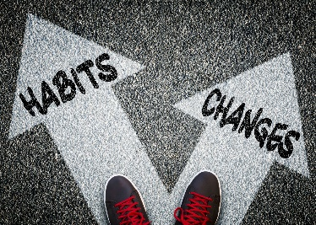
Thrive by Design: Building Strong Habits in 2024. On January 18, 2024 from 10-11 a.m. CT, explore the art of building strong habits in a virtual workshop led by Lacy Wolff, Coordinator for Statewide Well-being Initiatives. Set the foundation for a fulfilling year in this session as you step into 2024. You will be guided through practical strategies and exercises grounded in behavior change research. Thrive by Design Registration Link

More Resources:
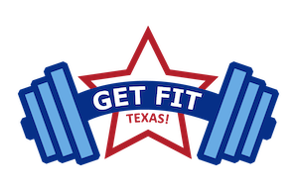
Join the Get Fit Texas! challenge: From January 22-March 31, this challenge will inspire you to get active in an agency-to-agency competition. By accepting the challenge, take on physical activity for 150 minutes per week for at least 6 of the 10 weeks of the challenge. Registration opens January 18th. Contact your agency’s Human Resources to find out about any rewards offered for completing the challenge.
Read an Article (<3 min read): Kick off this year with systems to reach your goals! In this quick read, “Be the Change you Want to See in your Life,” learn how identity-based habits and systems can help you to reach your goals in 2024 and beyond.
Download a habit tracker: Download our free digital habit tracker and start off 2024 using an evidence-based tool for creating behavior change. Decide what habits you want to focus on (smaller is better) and check them off day-by-day for long-lasting change!
Start a healthy lifestyle program: If you are a HealthSelect or Consumer Directed HealthSelect participant can join a no-cost progrm to support your nutrition, physical activity, sleep and stress. Check out Wondr Health and Real Appeal for more information and to apply today!
Listen to a podcast: Check our the library of resources available to learn about a health topic while you are on the go. Subscribe to the ERS Walk & Talk podcast wherever you listen to podcasts.
DAILY FITNESS & WELLNESS: Keep moving during January for free! Join encouraging fitness and mindfulness sessions featuring fitness instructors who are also state employees. The Work Well Texas Virtual Fitness offerings are year-round, weekday sessions that keep us moving TOGETHER! Check out the full calendar of events to join via Zoom from anywhere.

