July Social Media Posts

Social Media Post #1
Got questions about exercise? Join us for “Exercise as Medicine,” a special Q&A webinar on July 15th with Dr. Tim Church. Dr. Church is one of the country’s leading experts in exercise and obesity research and Chief Medical Officer for Wondr Health. Learn more and register for events through the ERS Wellness Events Calendar
Direct link to website: https://ers.texas.gov/Event-Calendars/Wellness-Events
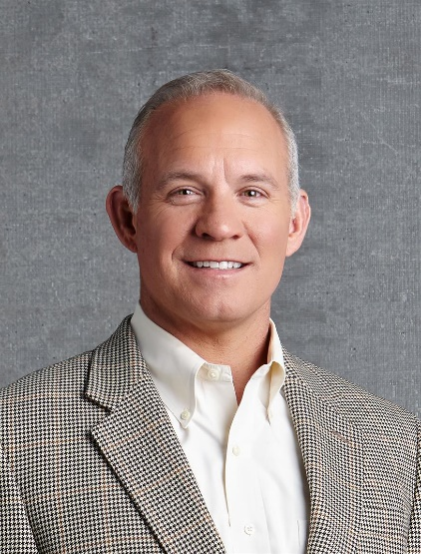

Social Media Post #2

Ready to get (or get back) to the gym? HealthSelect of Texas and Consumer Directed HealthSelect offers participants discounted access to local gyms and studios through the Fitness Program. Join in July and pay no enrollment fee with the code SUMMERFIT. See what is available in your community and learn more through this link:
https://healthselect.bcbstx.com/content/health-and-wellness-incentives/fitness-program
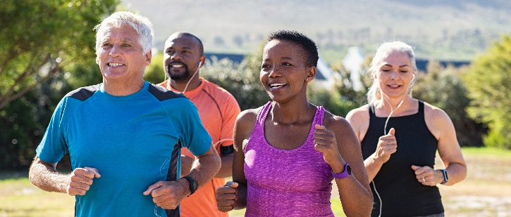

Social Media Post #3
Learn about the benefits of walking while you are walking through the latest ERS podcast episode featuring Dr. Tim Church! Search “ERS Walk and Talk” on major podcast streaming platforms or listen directly on the ERS Walk & Talk Webpage: https://erswalkandtalk.buzzsprout.com/

