July Social Media Posts

Social Media Post #1
Join us for a multi-agency fitness challenge! All classes can be found on new Virtual Fitness Calendar: http://www.wellness.state.tx.us/Challenge.htm Attend classes and log them for a chance to win fitness gear!
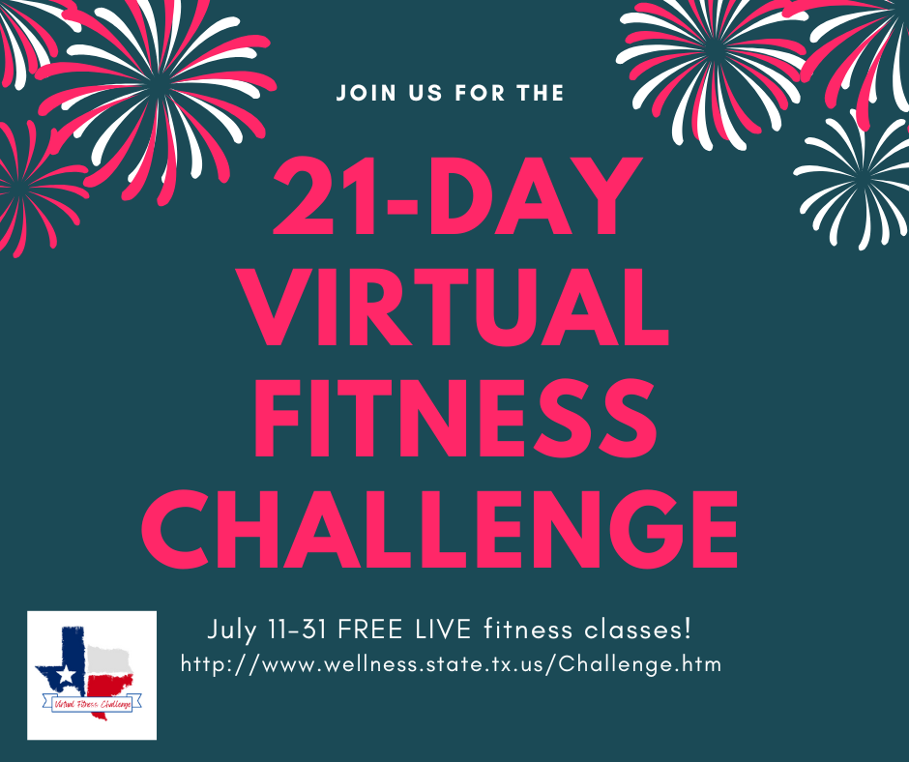

Social Media Post #2
Join Lacy Wolff and Alexis Schminke virtually on July 14th from 10-11 a.m. CT to learn creative ways to manage your expectations and turn our barriers into cues to motivate daily movement. Registration link: https://register.gotowebinar.com/register/711515288967360524

Social Media Post #3

Ready to get (or get back) to the gym? HealthSelect of Texas and Consumer Directed HealthSelect offers participants discounted access (and no contracts!) to local gyms and studios through the Fitness Program. Join in July and pay no enrollment fee with the code SUMMERFIT. See what is available in your community and learn more through this link:
https://healthselect.bcbstx.com/content/health-and-wellness-incentives/fitness-program
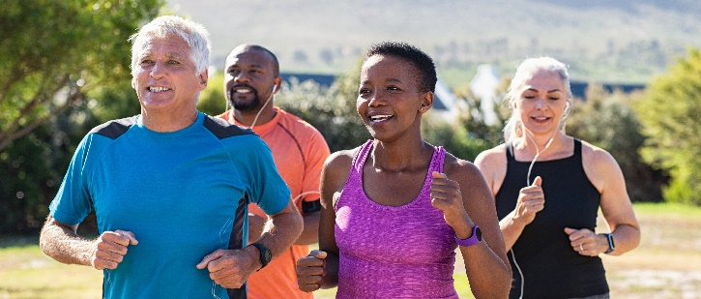

Social Media Post #4
Learn about health while you walk! Tune in to listen to the latest ERS Walk & Talk podcast episodes. The podcast is available on major podcast streaming platforms or listen directly on the ERS Walk & Talk webpage: https://erswalkandtalk.buzzsprout.com/

