July 2023 Newsletter Content:

Movement Mindset
Movement Mindset Webinar Register for the “Building a Movement Mindset” webinar with Lacy Wolff and Jewell Smith on July 6th from 10-11 a.m. CT. Often our own thinking creates the biggest barriers to engaging in physical activity. In this webinar we will explore creative ways to manage our expectations and turn our barriers into cues to motivate daily movement.
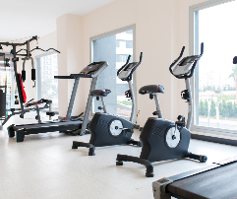
Join the Fitness Program! Use the code JULYFIT2023 to waive the enrollment fee during the month of July. The Fitness Program gives HealthSelectSM participants and covered dependents (age 16 and older) access to a network of fitness facilities. The digital only option lets you stay active from the comfort of your own home.
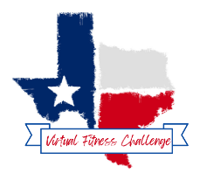
21-Day Fitness Challenge From July 10-30 participate in virtual fitness offerings, during each class we will get a “CODE WORD” you will use to log your attendance. Blue Cross and Blue Shield of Texas (BCBSTX) will provide prizes to top participants! Check out the Virtual Fitness Calendar to get started. No registration required!
Fitness & Nutrition Connect Community Calls Join the BCBSTX wellness team for 15- minute check-ins to connect with others and engage in a lively wellness discussion on a wellness topic. Check out the full schedule of events and register for sessions through the ERS Wellness Events Calendar.

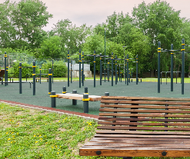
Creative Ways to Move with Holly Cuozzo, MS. Join us on July 20th from 10-11 a.m. CT to learn tips and tricks to build creative outdoor workouts. Holly Cuozzo of the Texas Department of Public Safety Fitness Wellness team will share principles of exercise, fun ways to add playground equipment into your programming, safety considerations and creative ways to exercise in the great outdoors.

