July Social Media Posts

Social Media Post #1
Join us for a multi-agency fitness challenge July 10-30! All classes can be accessed through the Virtual Fitness Calendar: http://www.wellness.texas.gov/Challenge.htm Attend classes and log them for a chance to win fitness gear!
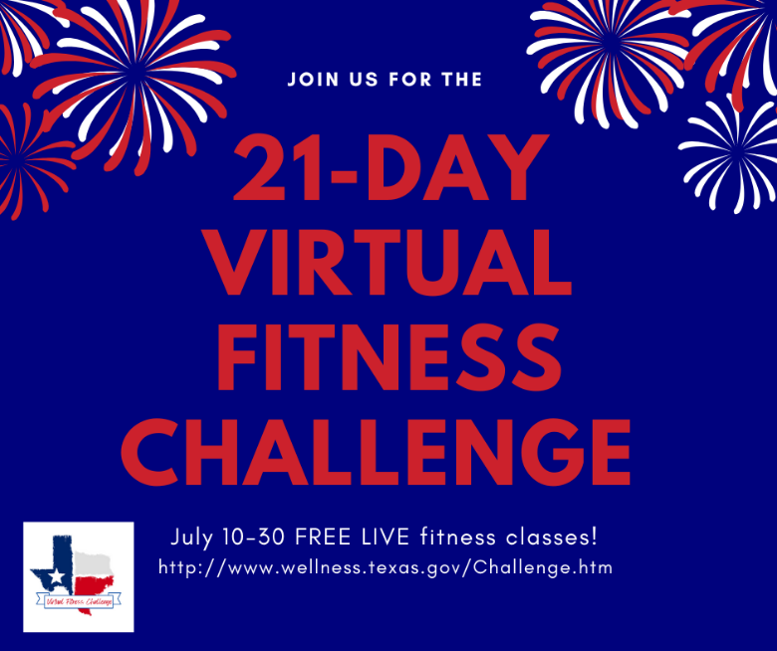

Social Media Post #2
Join Lacy Wolff and Jewell Smith virtually on July 6th from 10-11 a.m. CT to learn creative ways to manage your expectations and turn our barriers into cues to motivate daily movement. Registration link: https://register.gotowebinar.com/register/8947303790492140635

Social Media Post #3

Ready to get (or get back) to the gym? HealthSelect of Texas and Consumer Directed HealthSelect offers participants discounted access (and no contracts!) to local gyms and studios through the Fitness Program. Join in July and pay no enrollment fee with the code JULYFIT2023. See what is available in your community and learn more through this link:
https://healthselect.bcbstx.com/content/health-and-wellness-incentives/fitness-program
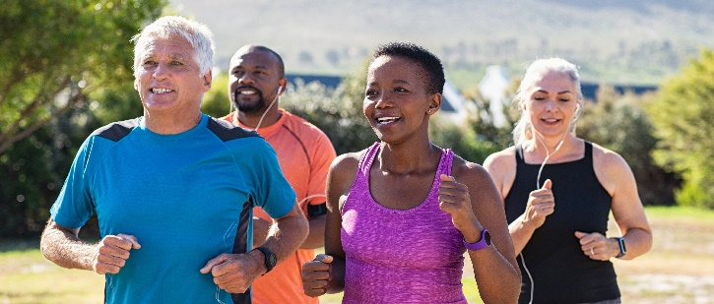

Social Media Post #4
Learn about health while you walk! Tune in to listen to the latest ERS Walk & Talk podcast episodes. The podcast is available on major podcast streaming platforms or listen directly on the ERS Walk & Talk webpage: https://erswalkandtalk.buzzsprout.com/

