March Social Media Posts:

Social Media Post #1
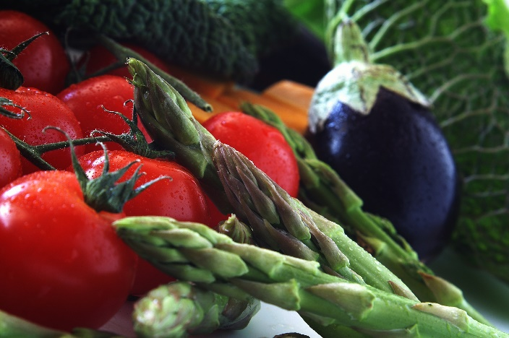

March is National Nutrition Month! ERS has teamed up with nutrition experts to discuss ways to enhance your nutrition, and up your nutritional knowledge! Join us each week to learn about simple tips to stay healthy, new easy recipes, the new dietary guidelines, and research behind current diet trends. Register for webinars through the ERS Wellness Events Calendar at Wellness Events | ERS (texas.gov)

Social Media Post #2

Health doesn’t have to be hard. Join Brian McFarlin, Ph.D, on March 10 from 10-11 a.m. to learn four simple and evidence-based strategies to improve health and well-being. Learn more and register here.

Social Media Post #3
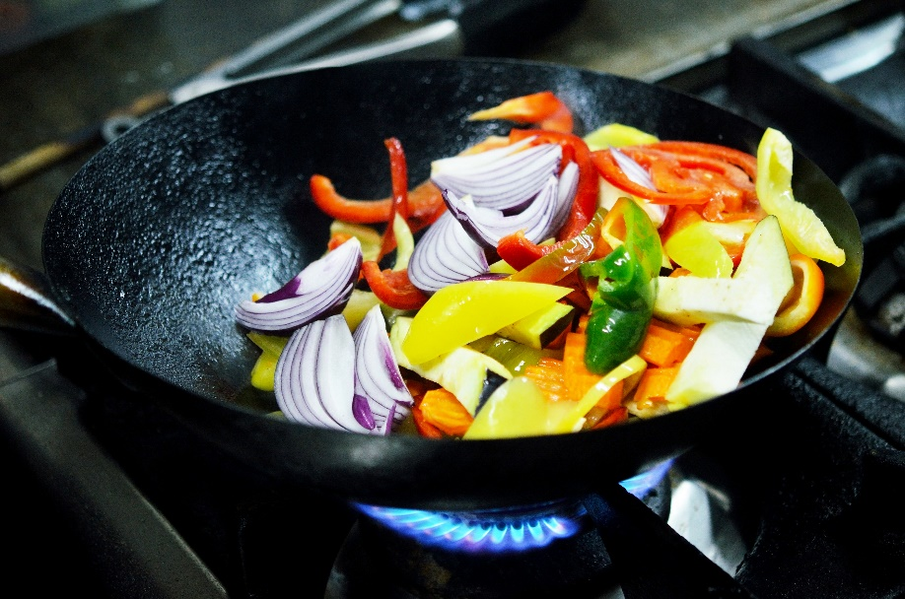

If you feel like you don’t have enough time in your day to prepare healthy meals or you want to spice up your current menu, this is the webinar for you! On March 10 from 10-11 a.m., Alexis Schminke, Certified Holistic Nutritionist from Texas DPS, will share tips and tricks for preparing healthy lunch and dinner options that you can have on the table in less than 30 minutes! Learn more and register here.

Social Media Post #4

As we learn more about nutrition science, the recommendations for what we should be eating have changed. On March 18 from 10-11 a.m., Holly Cuozzo of Texas DPS provides an overview of the most recent updates to the USDA guidelines and nutrition labels. Register through the ERS Wellness Events Calendar.
Social Media Post #5
Listen to your gut! On March 24 from 10-11 a.m. Brian McFarlin, Ph.D. will explain what our microbiome (AKA gut health!) is and how it contributes to our immune system. He will also delve into how our nutrition impacts gut health and what foods are best to establish a strong immune system. Learn more and register here.

Social Media Post #6
Intermittent fasting explained! Join Lindsey Menge MS, RD, LD on March 25 from 10-11 a.m. to learn about the ways intermittent fasting may positively impact metabolic health and blood sugar control, support cognitive function, and aid weight management. If you have tried, considered, or are just curious about intermittent fasting, please join us for this information-packed webinar where we will hear from a nutrition expert on this fascinating topic. Learn more and register here.

