November 2023 Newsletter:

Healthy Holiday Mindset

As you are preparing for the holiday season, don’t forget to take care of you! Join us this month for wellness opportunities to support your mental and physical well-being.
Keep moving during the holidays! Join the Fitness Connect Community and the Blue Cross and Blue Shield of Texas (BCBSTX) wellness team November 14, 10 - 10:15 a.m. CT, for a 15-minute check-in. Check out the full schedule of events and register for sessions through the ERS Wellness Events Calendar.

Journey to wellness: HealthSelect Wellness Benefits Overview Join the BCBSTX team, November 15 10-10:45 a.m. CT, for a 45-minute overview of your Well on Target portal, Blue Points, the Fitness Program and more! Register through the ERS Wellness Events Calendar
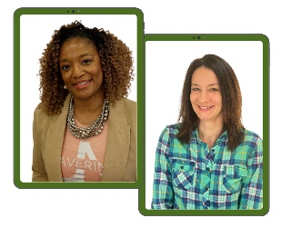
Healthy Holiday Mindset Join Lacy Wolff and Jewell Smith November 16, 10-11 a.m. CT, to discuss ways to embrace the holidays. In this fun and interactive webinar you will receive tips to help you remember what’s really important this holiday season, give gifts that won’t break the bank, and maintain your mental and physical well-being! Learn more and register through the Healthy Holiday Mindset registration link.
New! Train Your Brain with 10-minute Mindfulness meditation sessions. Join Lacy Wolff on Tuesdays and Thursdays during November from 10-10:15 a.m. to practice mindfulness meditation via Zoom. Check out the full calendar of events including Zumba, Yoga, Strength Training and more at the Work Well Texas Fitness Calendar
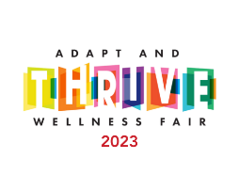
It’s not too late! If you missed the 2023 Virtual Wellness Fair you can still access all sessions, concerts and the Virtual Swag Bag. Access recordings through the 2023 Virtual Wellness Fair Event Channel

