November 2023 Social Media Posts
Diabetes Awareness Month
Share text: November is Diabetes Awareness Month. If you’re living with diabetes or prediabetes, Well onTarget® digital self-management programs can help you manage your condition and support your provider’s treatment plan. Programs include managing weight, nutrition and enhancing your physical activity.

[link to: https://healthselect.bcbstx.com/health-and-wellness-incentives/self-management]

Tobacco cessation program
Share text: Well onTarget® digital self-management programs can empower you to reach your health and wellness goals. Nov. 16 is the Great American Smokeout. Check out these programs that can help you quit using tobacco and stay tobacco free.

[Link to: https://healthselect.bcbstx.com/health-and-wellness-incentives/self-management]

Men’s Health
Share text: Men are less likely than women to get annual preventive checkups, according to the CDC, but it’s just as important for men to get preventive care as it is for women. Help increase your odds of living healthier and longer by making healthy choices, like getting regular preventive checkups, which are covered at no cost to you.

[Link to men’s health page: https://healthselect.bcbstx.com/medical-benefits/mens-health]

Weight management programs

Share text: With WondrTM or Real Appeal®, you can get the support you need to help you lose weight. Both weight management programs are available at no additional cost for eligible HealthSelectSM medical plan participants.

[Link to: https://healthselect.bcbstx.com/health-and-wellness-incentives/weight-management-programs]

New medical ID cards

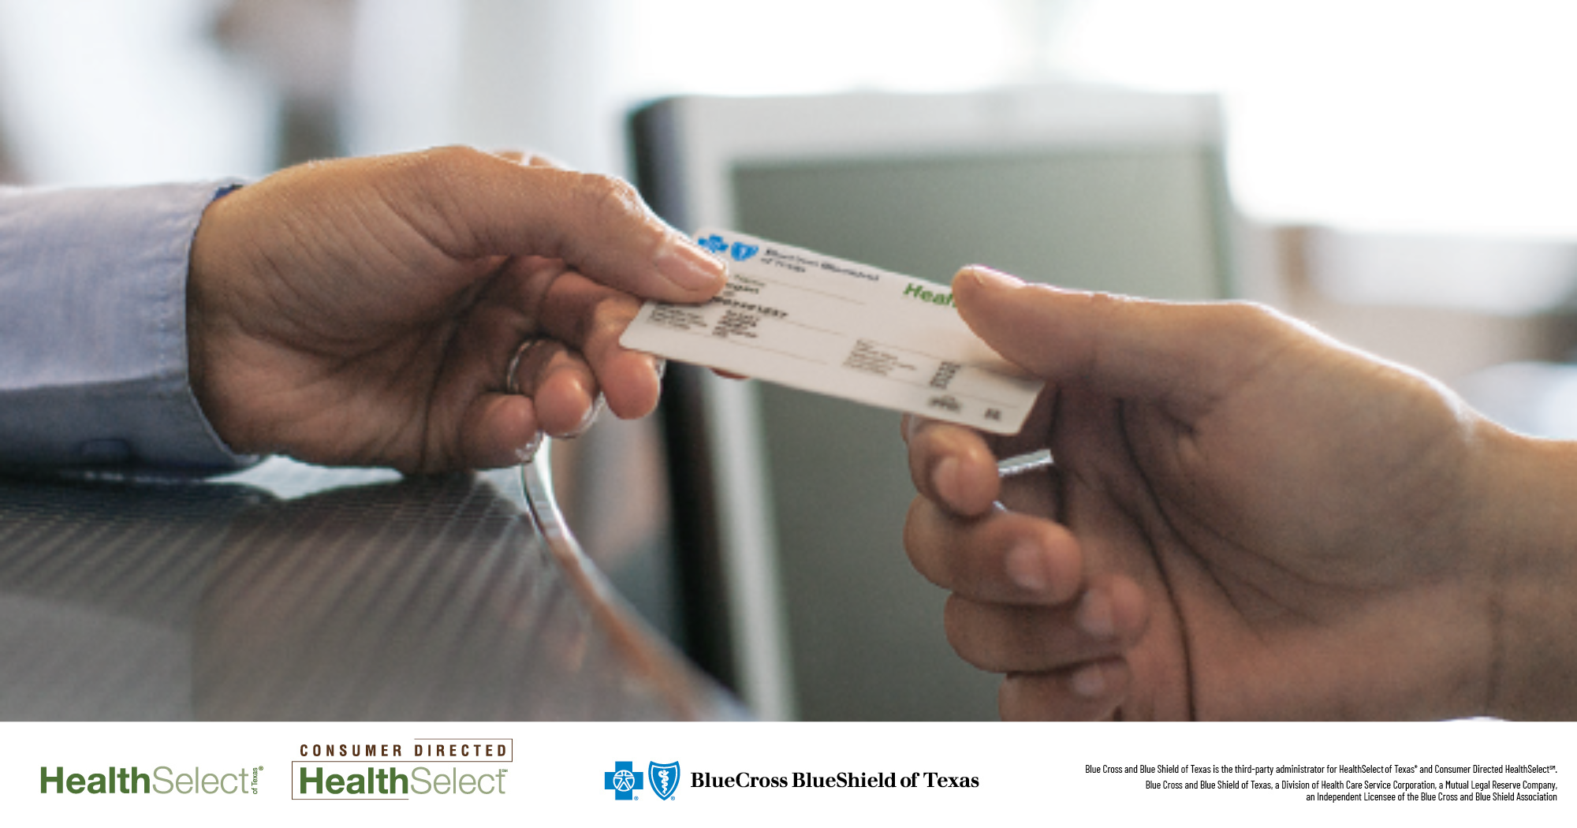

Share text: Be on the lookout for your new HealthSelectSM medical plan ID card in the mail the last two weeks of November. New medical ID cards will have your plan deductible and updated annual out-of-pocket maximum amount for 2024.
[Link to medical ID card page: https://healthselect.bcbstx.com/medical-benefits/medical-id-card]

