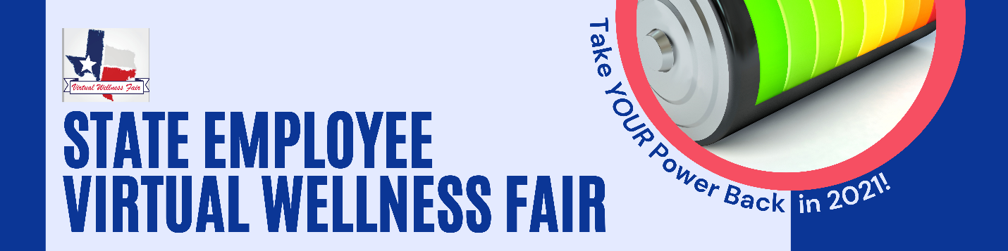

Promotional Email from Agency
Dear [insert agency or higher education institution] employees,

You are invited to attend a virtual wellness fair that is taking place from October 18-22. This event is filled with engaging and informative information on a wide range of topics.

Over the course of the week you have the opportunity to participate in:

- Wellness seminars featuring nationally recognized speakers
- a live cooking demonstration,
- daily fitness opportunities and
- daily 15 minute “Tiny Tele-desk Concert Series” featuring state employees that are also musicians!

This wellness fair is a great way to learn about the many benefits available to support you, and to have some FUN while recharging your inner-battery!

Check out this short promotional video with more details on presenters. Register for the event to receive a virtual swag bag and emails regarding upcoming events through this registration link.

Please direct questions and concerns regarding the event to wellness@ers.texas.gov

Sincerely,

Your Wellness Coordinator

