Social Media Posts

Social Media Post #1:
Insert YouTube Promotional Video for Virtual Wellness Fair: https://youtu.be/qJvFTFDpbBo
Insert text: State employees are invited to attend a Virtual Wellness Fair October 18-22nd! Learn more and register through this link: www.ers.texas.gov/virtual-wellness-fair

Social Media Post #2:
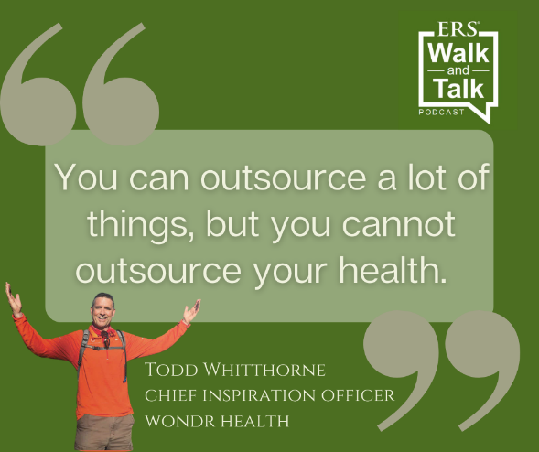
Insert Text: Be inspired with the Chief Inspiration Officer from Wondr Health in the latest Walk and Talk Podcast. Direct link to podcast: https://www.buzzsprout.com/1566635/9232017

Immunizations
Share text: Immunizations can help protect you and your family from serious illness this fall. Because vaccines don’t protect you right away, you shouldn't wait to get your shot. Remember: immunizations—like all preventive care--are covered at 100% by all HealthSelectSM plans, including Consumer Directed HealthSelectSM.
[Link to: https://healthselect.bcbstx.com/content/medical-benefits/preventive-care#immunizations]

Breast Cancer Awareness Month
Share text: October is Breast Cancer Awareness Month. This is a great time to make sure you’re taking care of yourself. Your HealthSelectSM medical plan covers preventive care, including annual well-women exams and preventive screenings like mammograms, at no cost to you.

[Link to: https://healthselect.bcbstx.com/content/medical-benefits/preventive-care]

Choosing a primary care provider
Share text: Having an in-network primary care provider (PCP) can help you get the highest level of benefits and save the most money. You can change your PCP at any time through Blue Access for MembersSM or by calling a BCBSTX Personal Health Assistant toll-free at (800) 252-8039, Monday-Friday 7 a.m. – 7 p.m. and Saturday 7 a.m. – 3 p.m. CT.
[Link to Selecting a PCP page on healthselectoftexas.com: https://healthselect.bcbstx.com/content/find-a-doctor-hospital/index]
Self-management programs
Share text: Well onTarget® digital self-management programs can help empower you to reach your wellness goals. October is Bone and Joint Health Awareness Month, so we’re highlighting the Healthy Bones and Joints self-management program.

[Link to: https://healthselect.bcbstx.com/content/health-and-wellness-incentives/self-management]

Medical Benefits Guide
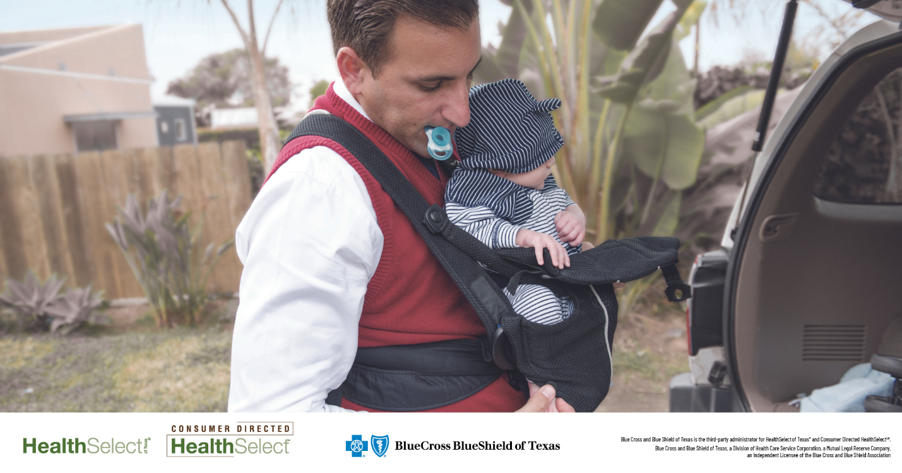

Share text: The new Plan Year 2022 Medical Benefits Guide is a great resource to learn about the health and wellness benefits available to all HealthSelectSM participants.
[Link to PY2022 medical benefits guide: https://www.bcbstxcommunications.com/ers/2020_medical_benefits_guide/index.html#p=1]

