October 2023 Social Media Posts

2023 Adapt & Thrive Virtual Wellness Fair

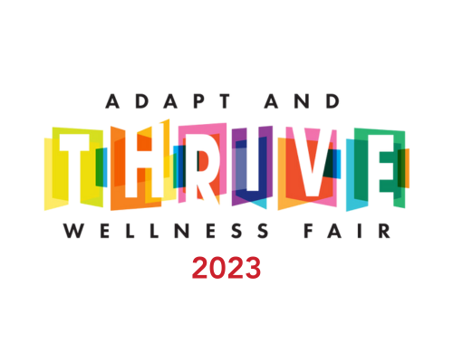
Share text: You are invited to attend the 4th annual Adapt & Thrive Virtual Wellness Fair! October 17-19 join us to hear engaging speakers, participate in virtual fitness opportunities and listen to afternoon concerts while you work. Registration link: https://event.gotowebinar.com/event/f180b565-e4ce-4d78-a8ea-ce366a7570f7

Fitness Program promotion
Share text: Get fit this fall! HealthSelectSM medical plan participants can sign up for the Fitness Program in the month of October and pay no enrollment fee with the code “OCTOBERWAIVED”.
Link to Fitness Program page: https://healthselect.bcbstx.com/health-and-wellness-incentives/fitness-program

Mammography
Share text: Most experts now recommend that women at average risk for breast cancer should start getting regular breast cancer screenings at age 40. Early detection is key, so talk to your doctor today about what’s best for you.
[Link to woman’s health page: https://healthselect.bcbstx.com/medical-benefits/womens-health]

Weight management
Share text: Get the support you need to manage your weight. WondrTM and Real Appeal® are available at no additional cost for eligible HealthSelectSM participants.

[Link to: https://healthselect.bcbstx.com/health-and-wellness-incentives/weight-management-programs]

