September Social Media Posts

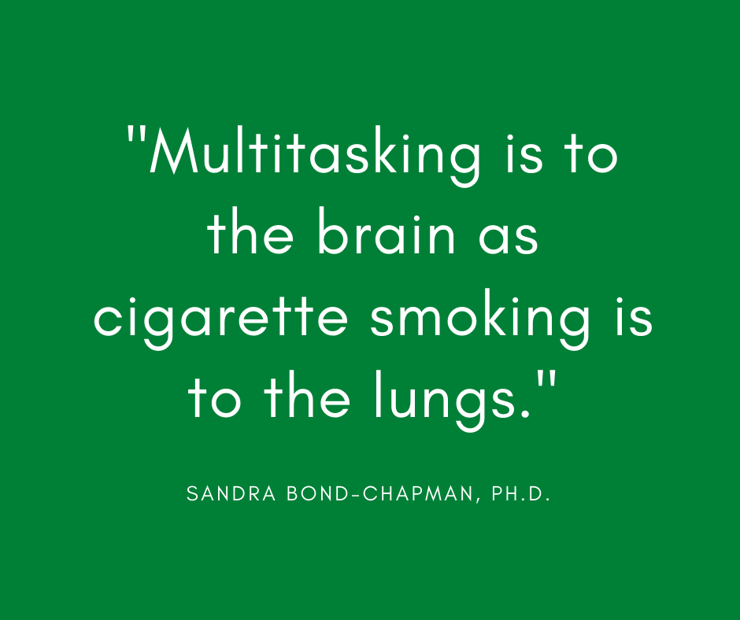
WEBINAR PROMOTION:
SHARE TEXT: Learn to build a resilient, smarter brain with Sandra Bond Chapman, Ph.D. September 9th from 10-11 a.m. CT. Dr. Chapman is the founder of the Center for Brain Health at the University of Texas at Dallas. Learn more and register for this event through the ERS Wellness Events Calendar: https://ers.texas.gov/Event-Calendars/Wellness-Events
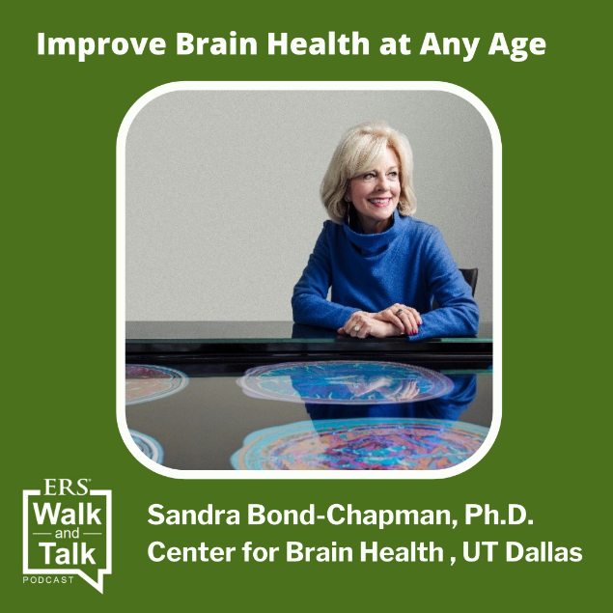
PODCAST PROMOTION:
Share Text: Learn how through the ERS Walk & Talk Podcast featuring Dr. Sandra Chapman. Include link: https://www.buzzsprout.com/1566635/9062558
Fitness Program promotion
Share text: Looking to get fit for the fall? Sign up for the Fitness Program with the code “SEPTWAIVED21” and pay no enrollment fee through September 30. Plus, all memberships now include online classes, including Les Mills workouts, so you can get a great work out from home.
Link to Fitness Program page: https://healthselect.bcbstx.com/content/health-and-wellness-incentives/fitness-program

Mental health Virtual Visits

Share text: If you struggle with mental health issues, you have support. HealthSelectSM coverage includes access to no-cost mental health Virtual Visits for those enrolled in HealthSelect of Texas®, HealthSelectSM Out-of-State and HealthSelectSM Secondary. Consumer Direct HealthSelectSM participants only pay 20% of the cost of a mental health Virtual Visit after meeting the annual deductible.

[Link to Virtual Visits page: https://healthselect.bcbstx.com/content/medical-benefits/virtual-visits#Mental%20Health%20Virtual%20Visits]

Choosing a primary care provider
Share text: Having an in-network primary care provider (PCP) can help you control costs, save time and improve your overall health. HealthSelect of Texas® participants must choose an in-network PCP to get the highest level of benefits and save the most money. You can change your PCP at any time through Blue Access for MembersSM or by calling a BCBSTX Personal Health Assistant toll-free at (800) 252-8039, Monday-Friday 7 a.m. – 7 p.m. and Saturday 7 a.m. – 3 p.m. CT.
[Link to Selecting a PCP page on healthselectoftexas.com: https://healthselect.bcbstx.com/content/find-a-doctor-hospital/index]

Immunizations video
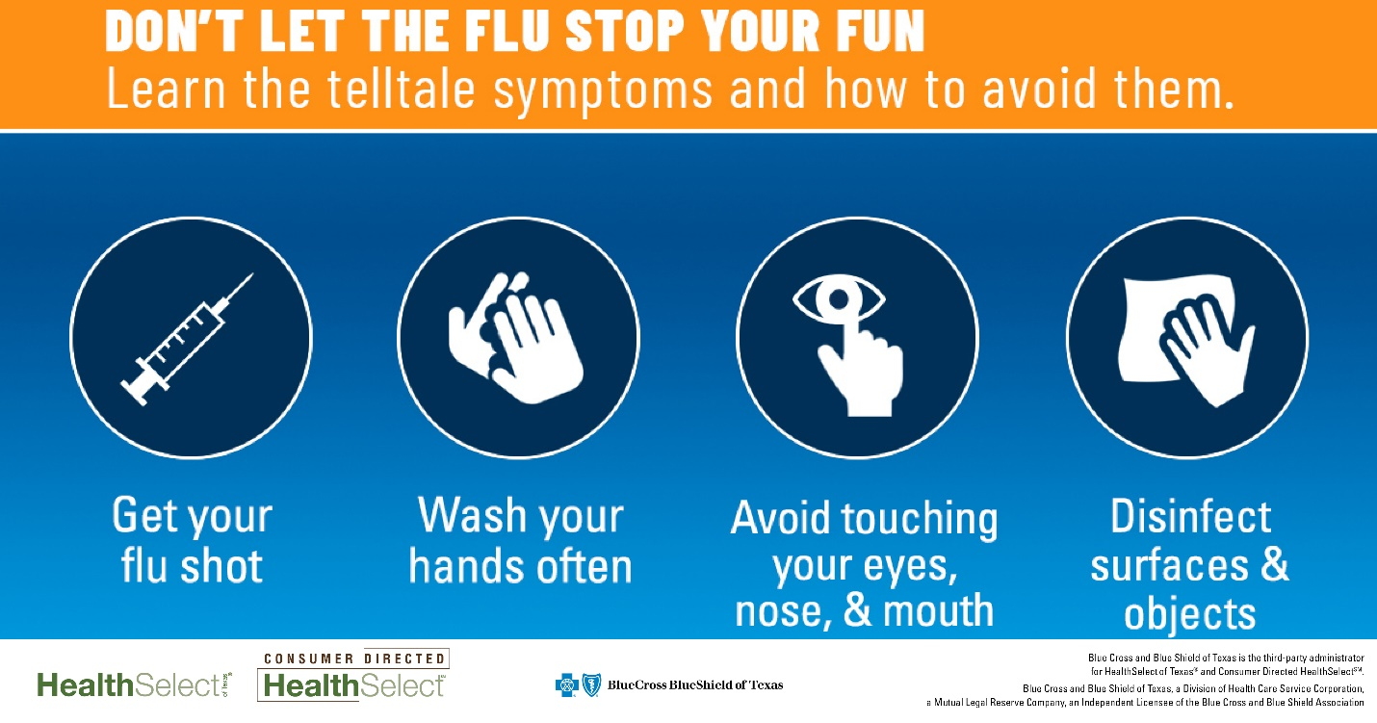
Share text: Remember, the flu shot takes about two weeks to start protecting you, so don’t wait until the middle of flu season to get your shot. Preventive care, including immunizations, is covered at 100% by all HealthSelectSM plans, including Consumer Directed HealthSelectSM.
[Link to: https://healthselect.bcbstx.com/content/medical-benefits/preventive-care#immunizations]

Medical Benefits Guide

Share text: The new Plan Year 2022 Medical Benefits Guide is here! It’s a great resource for answering questions about the health and wellness benefits available to all HealthSelectSM participants.
[Link to PY2022 medical benefits guide: https://www.bcbstxcommunications.com/ers/2020_medical_benefits_guide/index.html#p=1]

