September 2023 Newsletter:

Boost your Brain Health

This month, we're putting the spotlight on brain health – a vital aspect of our overall well-being. Discover valuable insights, engaging events, and practical resources that will help you enhance your brain and overall health!
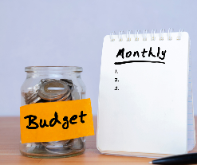
More Health, More WELLTH! Getting your finances in order can improve your overall health! Sign up to be a part of “More Health, More WELLTH,” a four-week financial wellness campaign starting Sept. 18. Over the course of four weeks, we'll guide you through practical strategies to improve your financial well-being. Information will be sent to you via email, text or both! Text TXERS Wellth to 468-311 to subscribe!
Boost your brain’s health with exercise! Join the Fitness Connect Community and the Blue Cross and Blue Shield of Texas (BCBSTX) wellness team, Sept. 12, 10 - 10:15 a.m. CT, for a 15-minute check-in and learn about the different ways physical activity can boost your brain health. Check out the full schedule of events and register for sessions through the ERS Wellness Events Calendar.

Tour the Blue Access for MembersSM Portal. Are you getting the most from your health plan benefits? Join the BCBSTX team, Sept. 19, 10 - 10:30 a.m. CT, for a 30-minute overview of your Blue Access for Members portal, the gateway to your health plan benefits! Register through the ERS Wellness Events Calendar

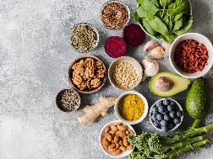
Healthy eating for a healthy brain! Join the Nutrition Connect Community and the BCBSTX wellness team, Sept. 26, 10 - 10:15 a.m. CT, for 15-minute check-ins to connect with others and learn about foods that can boost our brain health! Register for this session through the ERS Wellness Events Calendar.

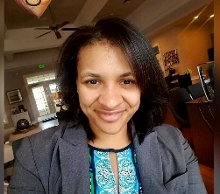
“Building Better Brain Health” Our brain has many important functions and is responsible for how we interact with the world around us. Our brains age, just like the rest of our body. Join ERS Wellness Consultant Valerie Johnson for this webinar on Sept. 28, 10 - 11 a.m. CT and learn lifestyle strategies that can support healthy brain aging. Participate in a fun activity to get your brain going! Brain Health Webinar Registation Link
Learn more about brain health through the following resources:
- Listen to a new ERS Walk & Talk podcast episode featuring Sandra Bond-Chapman, Ph.D. Director, University of Texas Dallas Center for Brain Health. Bond-Chapman discusses ways to improve brain efficiency.
- Learn how to build healthy habits and understand the science of the brain with
neuroscientist Russell Frohardt, Ph.D.

